1 General 1

1.1 JavaScript Versions 1

1.2 Additional resources 1

2 Style Guide 1

2.1 Linter 1

2.1.1 Prettier 1

To install per-project: 1

To Install in VSCode: 1

2.1.2 JSLint 1

2.1.2.1 Flags 1

2.1.3 ESLint 1

Install: 1

Configure 1

Run 1

3 Running In the DOM 1

3.1 DOM Manipulation 1

3.2 Event Handlers 1

3.3 MutationObserver 1

3.4 Optimizations 1

4 Require & Import 1

4.1 Require 1

4.2 Import & Export – ES6 and up 1

4.2.1 import 1

4.2.2 Export 1

4.2.2.1 Export Default 1

5 Data Types 1

5.1 Primitive date types 1

5.2 Type Coercion and Variable Mutation 1

5.3 Boolean 1

5.3.1 Equality 1

5.4 Number 1

5.5 Const 1

5.6 Strings 1

5.6.1 Template Literals 1

5.6.2 Performance 1

5.7 Arrays 1

5.7.1 Array Comprehension 1

5.8 Set 1

5.9 Objects 1

5.9.1 This Keyword 1

Binding Rules 1

New Binding rule: 1

5.9.2 Global Object 1

5.9.3 New Keyword 1

5.9.4 Prototypes 1

5.9.5 Lexical vs Dynamic Scopes 1

5.9.6 Object Creation Patterns 1

5.9.6.1 Constructor: 1

5.9.6.2 Object.Create 1

5.9.7 Objects Linked to Other Objects (OLOO) 1

5.9.8 Inheritance and Prototypes 1

Object keys: 1

Object notation 1

Properties 1

Functions 1

Mixin 1

5.9.8.1 Closure 1

5.10 Classes 1

5.10.1 ES5 and Below 1

5.10.2 ES6 1

5.10.2.1 This 1

5.10.2.2 Static Functions 1

5.10.2.3 Setters & Getters 1

6 Variables 1

7 Statements vs Expressions 1

8 Useful Functions 1

9 Functions 1

Gotchas 1

Default Arguments 1

The Rest Operator (args) 1

Static Variables 1

9.1 Function Types 1

9.2 Function Expressions 1

The Spread (unpack) Operator 1

Destructuring Assignment 1

9.3 Immediately Invoked Function Expression (IIFE) 1

9.3.1 Create a Module Using IIFE 1

9.4 Pure Functions 1

9.5 Common Functions 1

9.6 Anonymous Functions 1

9.6.1 ES5 and Below 1

9.6.2 Arrow Functions (in ES6) 1

9.7 Curried Functions 1

9.8 Partial Application 1

10 Module Pattern 1

10.1 Factory Functions 1

10.2 ES6 Modules 1

10.2.1 Import 1

10.3 ES6 Modules and Node.js 1

11 Regular Expression 1

11.1.1 Test method – on regex 1

11.1.2 Match method – on string 1

11.1.3 Create a Regular Expression 1

11.1.4 JS Regex Patterns 1

11.2 $ 1

12 External Functions 1

12.1 Web API 1

13 Behind the Scenes 1

13.1 Execution Context 1

13.1.1 Default Execution Context = Global Execution Context 1

13.1.2 Function Execution Context 1

13.1.2.1 Execution Context Stack 1

13.1.3 Event Loops 1

13.1.3.1 Multithreading: 1

13.1.3.2 The Main Thread 1

13.1.3.3 Event Loop 1

13.1.3.4 Render Queue 1

13.1.3.5 Microtasks Queue 1

13.1.3.6 Compositor 1

13.1.3.7 Event Loops 1

13.2 Scope 1

13.2.1 Compilation Time 1

13.2.2 Execution Time 1

13.2.3 Block Scope 1

13.3 Hoisting 1

13.4 Closure 1

13.5 Global Scope Issue 1

14 Program Flow 1

14.1 Conditions and Loops 1

14.2 Evaluators 1

14.3 Functions 1

14.4 Exceptions 1

14.4.1 Throw: 1

14.4.2 Try-Catch: 1

15 Input/Output 1

16 Asynchronous Programing 1

16.1 Callbacks 1

16.2 Promise 1

16.2.1 Promises 1

16.2.2 Promises Chaining 1

16.2.3 Example 1

17 AJAX – Asynchronous JavaScript & XML 1

17.1 Connect to DOM 1

17.2 Change Element Content 1

17.3 XMLHttpRequest 1

17.4 Event Listeners 1

18 JSON 1

18.1 Get and manipulate elements on a page: 1

18.2 Always Lint your JSON! 1

19 TypeScript 1

19.1 Install 1

19.2 Compile to JS 1

19.3 Create New React-Redux-Typescript Project 1

19.4 Syntax 1

19.4.1 Type Annotations 1

19.4.2 Interfaces 1

19.4.3 Classes 1

Public/Private/Protected 1

ctor 1

Functions 1

Accessors (Properties in C#) 1

19.4.4 Operations 1

19.4.5 Extend React.Component 1

19.4.5.1 Type Assertions 1

19.5 Testing 1

19.5.1 Enzyme 1

20 Libraries 1

20.1 Useful Libraries 1

20.2 JQuery 1

21 Tools 1

21.1 Bundling 1

21.1.1 Parcel 1

21.2 Compilers 1

21.3 Toolkits 1

22 NodeJs 1

23 Testing 1

23.1 Unit Testing 1

23.1.1 Mocha 1

Install: 1

Set Up: 1

Structure 1

Assertion Libraries (e.g. Chai): 1

Running 1

Debugging 1

23.2 Chai 1

23.2.1 Installation 1

Node.js 1

Browser 1

23.2.2 Test 1

23.3 End-To-End Testing 1

23.3.1 Cypress 1

Install: 1

24 How to debug 1

24.1 Chrome Debugging 1

25 Packaging 1

25.1 Npm 1

25.1.1 Init 1

25.1.2 Install Dependencies 1

25.1.3 Install Package 1

25.1.4 Run local host server 1

25.1.5 Useful Commands 1

25.2 Yarn 1

25.3 Package.json 1

26 Resources 1

# General

* <https://developer.mozilla.org/en-US/docs/Web/JavaScript> - open wiki. We can update sign it and update it.
* Recommended style guide: <https://github.com/rwaldron/idiomatic.js>
* js spec: <http://www.ecma-international.org/ecma-262/5.1/>
* You don’t know JS: <https://github.com/getify/You-Dont-Know-JS>

JavaScript is a

* Lightweight, cross platform, object-oriented
* Dynamic – compile just in time (Just In Time – JIT) into a binary byte code – while the browser is loading the JS and just before the JS Virtual Machine executes it. This means that static errors in the code will be discovered before it starts execution.
* weakly typed,
* prototype-based language with
* first-class functions: functions that can be treated like any other values. This means that they can be assigned to variables, be in arrays and returned from other functions.
* Multi-paradigm language. Meaning is allows using multiple programming paradigms together - OO, procedural and even functional programming.
* **Javascript** is always pass by value, but when a variable refers to an **object** (including arrays), the "value" is a **reference** to the **object**. Changing the value of a variable never changes the underlying primitive or **object**, it just points the variable to a new primitive or **object**.

JavaScript == ECMAScript == Jscript

JavaScript != Document Object Model (DOM)

ECMAScript is a standardized version of JavaScript with the goal of unifying the language's specifications and features. As all major browsers and JavaScript-runtimes follow this specification, the term *ECMAScript* is interchangeable with the term *JavaScript*.

The most recent standardized version is called ECMAScript 6 (ES6), released in 2015.

## JavaScript Versions

* ECMAScript – the language standard
* JavaScript – the language name
* ES5 (ECMAScript 5) – is the main ‘old’ release
* ES6 (ES2015 : ECMAScript 2015) – is the main ‘new’ release with the biggest update to the language.
* 2015: Changed to smaller, annual release cycle.
* Future versions of JavaScript are called together **ESNext**

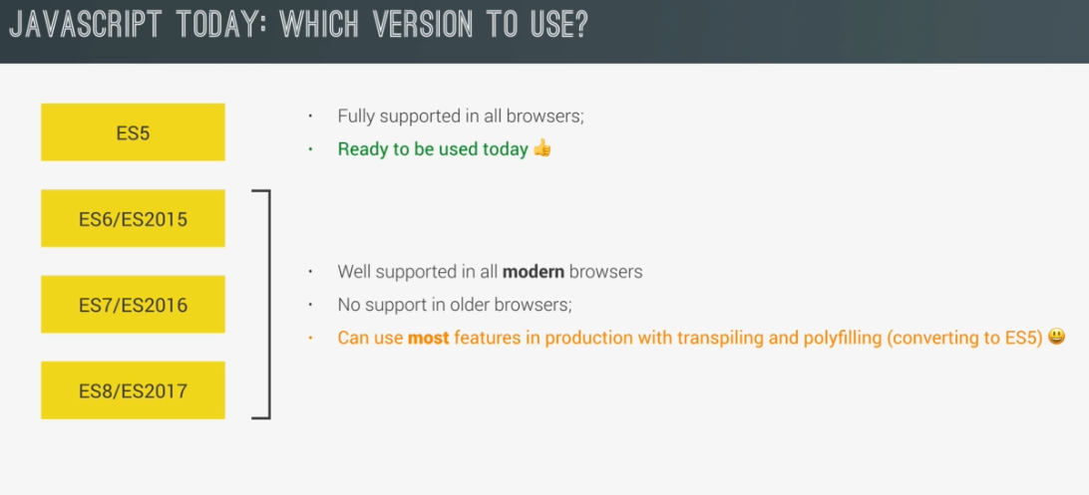

To check which feature is supported in which browser: <http://kangax.github.io/compat-table>

* The recommendation is for developers to focus on writing the clean, **new syntax forms**, and **let the tools take care of** producing a forwards-compatible version of that code that is suitable to deploy and run on the oldest-supported JS engine environments (through transpilers).
* Sometimes, if a transpiler doesn’t support a new feature, you might need to search for a polyfill for the feature. This is a code that defines the missing function. When using a polyfill try using a published, reliable polyfill instead of writing your own.

## Additional resources

* JS (ECMAScript) official spec: <https://262.ecma-international.org/>
* Previous versions: [https://www.ecma-international.org/ecma-262/{version}/](https://www.ecma-international.org/ecma-262/%7bversion%7d/) for example: <https://www.ecma-international.org/ecma-262/10.0/>
* You Don’t know JS: <https://github.com/getify/You-Dont-Know-JS/blob/2nd-ed/get-started/ch1.md>

<https://github.com/jonasschmedtmann/complete-javascript-course>

<http://codingheroes.io/resources/>

* Babel: <https://babeljs.io/>
* Jest: <https://jestjs.io>
* Typescript: <https://www.staging-typescript.org/>

# Style Guide

The [Mozilla Developer Network (MDN)](https://developer.mozilla.org/en-US/) is a fantastic resource for all things web and [JavaScript](https://developer.mozilla.org/en-US/docs/Web/JavaScript)

Style Guide: <https://google.github.io/styleguide/javascriptguide.xml>

* Variable, function names: camelCase
* Files/modules names: lower_case_with_underscore.js
* const IN_ALL_CAPITALS
* “use strict”; - as the 1st line in every file!!
* Use let or const. Never var!
* Always use ‘;’ at the end of java script command.
* Prefer // to /*..*/ for comments!
* Kyle recommend using global.myVar to explicitly mark a global variable that I declare (or use) inside an IIFE.

## Strict Mode

Strict mode helps the JS Engine to detect more errors during the compilation time as well as help developers write better, less error-prone code.   
Therefore, you should put this at the very top of every JS file:

// only whitespace and comments are allowed

// before the use-strict pragma

**"use strict";**

// the rest of the file runs in strict mode

Warning: even a “;” before the “use strict”; line will turn the strict off mode silently without any errors/warning!

* There should be a linter option to force use strict clause.

Strict mode can alternatively be turned on per-function scope, with exactly the same rules about its surroundings:

function someOperations() {

// whitespace and comments are fine here

"use strict";

// all this code will run in strict mode

}

* ES6 modules assume strict mode

## Linter

### Prettier

A very opinionated auto-formatting tool for javascript

##### To install per-project:

1. To install:

> npm install -D prettier

The reason you have to install it like this even if you have this extension in your VSCode is so that other devs will also have it automatically.

1. create a .prettierrc file in the root directory with the prettier configuration for the project. You can add just {} if you want all the defaults.
2. In package.json under “scripts”, add "format": "prettier --write \"src/**/*.{js,jsx}\""
3. to run: > npm run format

##### To Install in VSCode:

1. install it through extensions
2. Open settings and search for:
   1. Format on Save – check
   2. Prettier: Require Config – check – this make sure to run the prettier only when there is a prettierrc file in the project.

### JSLint - old

<http://jslint.com/help.html>

The most common JS linter is jslint.

To install:

npm install -g jslint

#### Flags

To control the jslint behavior, add the following at the start of your files:

* Allow console outputs (console.log):

/*jslint devel: true */

**NOTE:** Make sure to remove this from production code!!

* Allow whitespcaes at the end of the line:

/*jslint white:true */

### ESLint – Recommended

<https://eslint.org/docs/user-guide/getting-started>

Allow better customization of all the rules used by the linter. This is more flexible than JSLint.  
ESLint recommend installing it locally, at each project.

##### Install:

npm install eslint –save-dev

or, as recommended in course – this version is pretty lack but a still good version of ESLint:

npm install -D [eslint@7.18.0](mailto:eslint@7.18.0) eslint-config-prettier@8.1.0

##### Configure

1. create a configuration file:   
   npx eslint -–init
2. Update the “extends” parameter to be:

"extends":[

        "eslint:recommended", // less opinionated set of rules

        "prettier"

    ]

1. Add another script in your package.jason:  
   "lint": "eslint \"src/**/*.{js,jsx}\" --quiet"

##### Run

In the terminal: npm run lint

To remove errors for things (like React) that are supported but not recognised, you can add

/* global React, ReactDOM */

At the top of the file.

* With npm scripts, you can pass additional parameters to the command if you want. Just add a -- and then put whatever else you want to tack on after that. For example, if I wanted to get the debug output from ESLint, I could run npm run lint -- --debug which would translate to eslint **/*.js --debug.
* We can use our fix trick this way: npm run lint -- --fix.
* **To ignore an error** on a specific error/line that you know is fine, you can add // eslint-disable-line react-hooks/{rule-name} on the line. You can see the rule-name in the error message For example:  
  // eslint-disable-line react-hooks/exhaustive-deps

##### Support React

For ESLint to recognise and support React and JSX syntax:

1. Install:  
   npm install -D eslint-plugin-import@2.22.1 eslint-plugin-jsx-a11y@6.4.1 [eslint-plugin-react@7.22.0](mailto:eslint-plugin-react@7.22.0)
2. Update your .eslintrc.json to:

{

"extends": [

"eslint:recommended",

"plugin:import/errors",

"plugin:react/recommended",

"plugin:jsx-a11y/recommended",

"prettier",

"prettier/react"

],

"rules": {

"react/prop-types": 0,

"react/react-in-jsx-scope": 0

},

"plugins": ["react", "import", "jsx-a11y"],

"parserOptions": {

"ecmaVersion": 2021,

"sourceType": "module",

"ecmaFeatures": {

"jsx": true

}

},

"env": {

"es6": true,

"browser": true,

"node": true

},

"settings": {

"react": {

"version": "detect"

}

}

},

# Running In the DOM

When we have the following HTML:

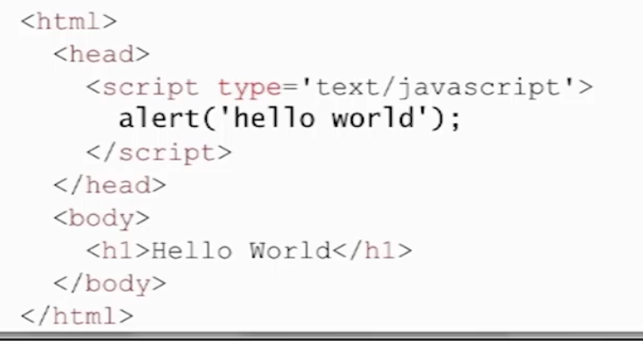

What actually happens when we do to its site:

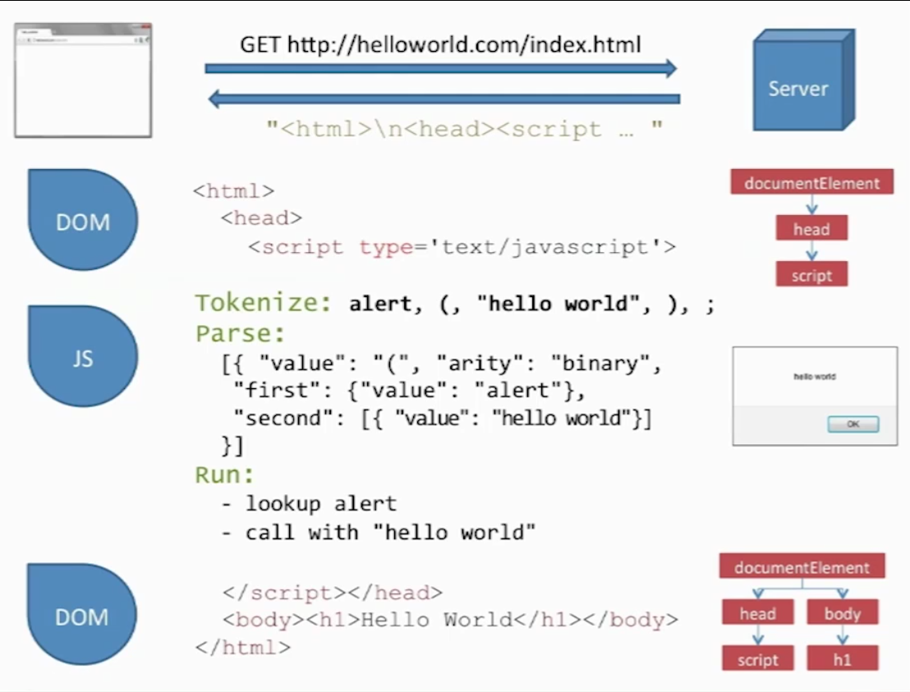

1. The browser sends an http request to the server
2. The server returns the html as a string
3. The browser pass it off to its web engine to process the html and build the DOM objects from it (documentElement etc)
4. When it see the java script, it will pass it to the JS engine (e.g. V8).  
   NOTE: **The browser hangs the processing of the page while it waits for the JS engine to process the script!**
5. The JS engine will tokenize and parse the script (i.e. ‘compile’ it to byte code) and execute it.
6. After the JS Engine has finished, it will return control to the DOM to keep parsing the html.
7. The DomContentReady will run only after the DOM finished processing the whole body of the html (after the </body>

## DOM Manipulation

* document – the DOM as an object we can query
* document.querySelector() – allow us to get access to an element in the DOM. Uses the same selectors as in CSS. Examples:

document.querySelector(  
'#current-' + activePlayer).innerHTML = `<em> ${dice} </em>`;

var x = document.querySelector(`#score-${activePlayer}`).textContent;

* getEelementById – a faster way to get elements by their Ids.
* Elements attributes can usually be accessed directly. For example:  
  document.querySelector('.dice').src = `dice-${dice}.png`;  
  document.getElementById(‘score-0’).style.display = ‘none’;
* Add/remove/toggle class to an element – use the classList property of the element:  
  document.querySelector(`.player-1-panel`)**.classList.toggle**('active');

## Event Handlers

* An event can **only** be handled when the **execution stack is empty**. Meaning there are no running functions!
* All the events in the page are entered into a **queue** and there they await execution in a FIFO order.

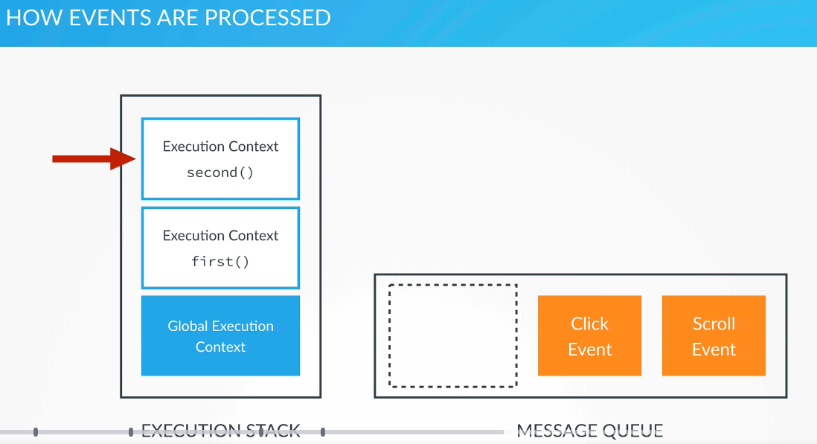

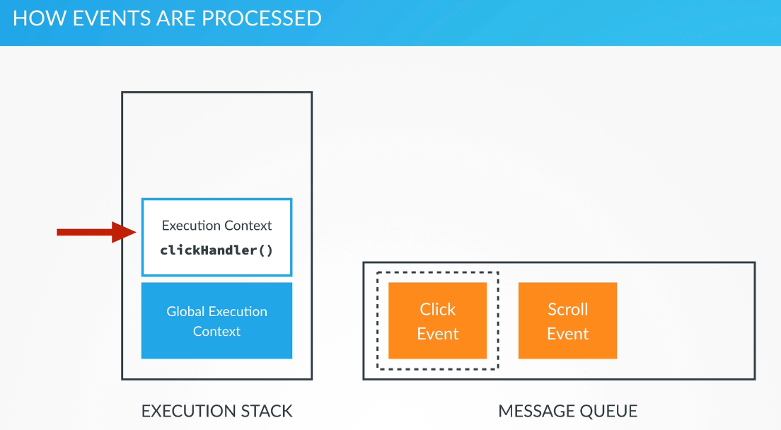

To add an event handle to elements:

let element = document.getElementById(“elementId”);  
element**.addEventListener**(“<event>”, eventHandlerFunction);

## MutationObserver

If you need to monitor the DOM for changes and register a callback function to handle them, you can use MutationObserver: <https://developer.mozilla.org/en-US/docs/Web/API/MutationObserver>.

See some [rules of thumb](https://stackoverflow.com/questions/31659567/performance-of-mutationobserver-to-detect-nodes-in-entire-dom/39332340) for working with MutationObserver.

## Optimizations

* You should put your **JS at the bottom of the html** and not at the start of it so your users will see something while the JS is processing. Otherwise, the loading of the page will hang while the JS process the script.
* To make sure your code executes only after the page has finished loading, you can attached a JavaScript ‘DOMContentLoaded’ event to the document:

document.addEventListener('DOMContentLoaded',  
 function() {  
 ….   
// You can register additional event handlers here. For example: document.getElementById(‘getMessage’).onclick=function() {…};  
});

# Require & Import

## Require

Will import **all the functions and code** from the required module

In strict mode (“use strict”):

1. In the exporting module add the following at the buttom:

module.exports = {

<exported name>: <function/class/variable name>,  
 …

};

For example:

module.exports = {

palindrome: palindrome,

};

1. In the importing module add the following at the top:

let <local name> = require<path for module>.<exported name>;

for example:

let palindrome = require("../palindrome_checker").palindrome;

Note: the require clause can also contain only the module’s name in order to include all the exported parameters.

## Import & Export – ES6 and up

### import

To import the default export from a module:

**Import** defaultExport from “module-name”;

NOTE: if you put {} around the defaultExport, it will not work.

Allow us to chose which parts of a module/file to load into a given file:

**import** { <funct/var name> } **from** "<file_path>";

to import everything from a file:

**import * as** <imported object name> **from** “<file path>”;

to import a list of functions/objects and (optionally) supply a more user-friendly name for them:

**import** {func1 **as** alias1, func2 as alias2, var1, …} from “module-name”;

**Notes:**

* The Import and Export are both non-browser features!!
* The whitespace surrounding the function inside the curly braces is a best practice - it makes it easier to read the import statement.
* In most cases, the file path requires a ./ before it; otherwise, node will look in the node_modules directory first trying to load it as a dependency.

Dynamic Import: since ES2020, js support dynamic import (only when needed) via the import() function call:  
  
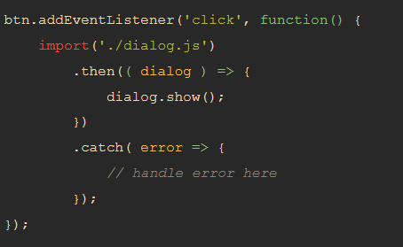

### Export

For each file, we need to declare which functions and variable can be imported from the outside, using the export statements:

const capitalizeString = (string) => {  
  return string.charAt(0).toUpperCase() + string.slice(1);  
}  
const foo = "bar";  
**export** { capitalizeString, foo }

We can also write a separate export statement for every function/variable separately:

export { capitalizeString } //How to export functions.  
export const foo = "bar"; //How to export variables.

#### Export Default

export default function add(x,y) {  
  return x + y;  
}

**Note:** Since export default is used to declare a fallback value for a module or file, you can only have **one value be a default export in each module or file**. Additionally, you cannot use export default with var, let, or const

To import an export default, you need to use this special syntax (without the curly brackets):

import add from “math_functions”

# Data Types

undefined, null, boolean, string, symbol, number, and object.

We don’t declare the type of the variable explicitely.

## Primitive date types

The Primitive date types (that are not objects) in js are **value types**. They are:

* Number: floating point numbers, for decimals and integers
* String
* Boolean (see below)
* Undefined: data type of a variable that does not have any value yet
* Null:

## Type Coercion and Variable Mutation

* Type coercion – javascript ability to automatically convert the type of variables to the required type (for example: console.log(5);)
* Variable mutation – javascript ability to change the type of the variable dynamically according to its current value:  
  var varMutation = “now I’m a string”;  
  varMutation = 5;

## Boolean

**Truthy** values in JS are values that are not defined as Boolean but will evaluate to true when evaluated in a Boolean context.

Here are the **falsy** values:

* false
* null
* undefined
* The empty string ''
* The number 0
* The number NaN

All other values are truthy, including true, the string 'false', and all objects.

### Equality

* == (double ‘=’) – will compare that values and if they are of different types (for example, numbers and strings), it **will automatically convert one type to another**. This is known as "Type Coercion".
* **Strict equality** (**===**) is the counterpart to the equality operator (==). However, unlike the equality operator, which attempts to convert both values being compared to a common type, the strict equality operator does not perform a type conversion. Strict inequality (!==) is the opposite of ===.

## Number

JavaScript has a single number type. Internally, it is represented as 64-bit floating point, the same as Java’s double. Unlike most other programming languages, there is no separate integer type, so 1 and 1.0 are the same value. This is a significant convenience because problems of overflow in short integers are completely avoided, and all you need to know about a number is that it is a number. A large class of numeric type errors is avoided.

The value NaN is a number value that is the result of an operation that cannot produce a normal result. NaN is not equal to any value, including itself. You can detect NaN with the isNaN( number ) function.

The floating point can cause precision errors unlike when working with decimals or integers in other languages. The ways to avoid this is:

* Write a round function that translate the number to whole number and then use Math.round to round it before translating it back:

function roundToCents(floatingValue) {

return (Math.round(floatingValue * 100) / 100);

}

* Another option is to drop the decimal point completely, translate the problem to whole numbers problems and translate back at the very end to supply the answer.  
  For the example above, if we need to do arithmetic calculations on dollars and cents, we can translate the algorithm to work with cents only and translate the results to dollars and cents at the very end.

## Const

* Note: const prevents re-assignment of the value. It does not prevent mutating the value for mutable types (e.g. arrays):  
  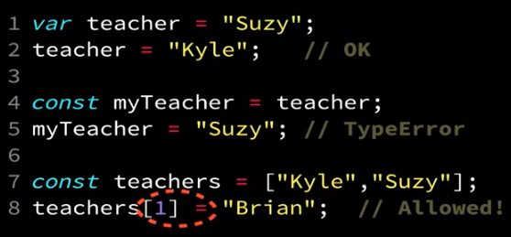
* Best practices: use const just with primitive, immutable values and only when you use it as a semantic place-holder for this value (e.g. const MAGICAL_NUMBER = 13; ….. console.log(MAGICAL_NUMBER);)
* In order to prevent accidental changing of variables, use .freeze instead. Note: .freeze is a shallow freezing of the object so it doesn’t fully protect it but it still offers some protection.

## Strings

* Immutable

JS accept both single-quoted and double-quoted strings (‘ and “).

* **concatenation**: + and +=
* **.length**

str**.split**(<split in substring>) e.g. “my string”.split(“ “) === arr[“my”,”string”]

* .replace(<regex>,<value or function to return the value>);
* . trim to remove whitespaces from start/end.
* All characters in JS are 16 bits wide. JS doesn’t have a character type. In order to represent one character, use a 1-length string.

### Template Literals

* **` (backtick)** allow you to add newlines in the code of the string instead of using \n
* ${variable} placeholder – can be used to pass on a variable to an expression
* To interpolate variables inside a string:

**`**String text **${**expression**}`**

### Performance

* In old browsers, it looks like there was a performance benefit for using ‘+’ instead of template literals. However,
* In more modern browsers, template literals are the fastest (as of start of 2020), followed by ‘+’ with concat function last. Therefore
* Recommendation:
  + **Use template literals where possible**. If not,
  + Use ‘+’ operator.

## Arrays

* **Mutable**

var myArray = **[**1, “string”, 7.4, [4]**]**;

var anotherArray = **new Array(**1,5,”hello”**)**;

* arr.length
* arr**.push**(val) – push val to the **end** of the array.
* val = arr**.pop**() – pop val from the **end** of the array.
* arr**.unshift**(val) – add val to the **beginning** of the array.
* val = arr**.shift**() – remove and return the **first** element of the array.
* arr.indexOf({val}) – will return the index of the val or -1 if doesn’t exist.
* arr.filter(test-function) - The filter() method creates an array filled with all array elements that pass the test-function. It does not change the original array!
* arr.map(func) - Creates a new array with the result of calling a function for each array element
* arr.find(func) – return the 1st element in the array that returns true for the func. Example: ages.find(olderThan13);
* add/remove items to and array. Return the removed items   
  **arr.splice**(<from index>,<number of elements to remove>, <list of items to add>)
* **arr.slice**(<from index>,<until index exclusive>)  
  return the sub-array.
* **arr.forEach(<callback function>)**
* **Cloning Arrays:**let rainbowClone = […rainbow];

**Or:**

let rainbowClone = rainbow.slice();

### Array Comprehension

Javascript doesn’t support array comprehension like in Python (it is partially supported in a non-standardized way and not supported by Firefox). Instead, use:

Array.from({**length:** 5}, (_, i) => i * 2);

## Set

let animals = new Set(‘pig’, catObject,..);

## Objects

(almost) everything is an object in javascript. Everything except the primitive data types (e.g. int, etc).

Objects in JavaScript are mutable keyed collections. In JavaScript, arrays are objects, functions are objects, regular expressions are objects, and, of course, objects are objects.

All **objects** in js are **reference types**.

There are **no classes in JS**! We can define an object using **object literal notation** in the following way (similar to python’s dictionaties):

**var <object_name> = {  
 <key (== property)> : <value>,  
 <key> : <value>  
};**

for example:

// object literal definition

var john = {  
 firstName: ‘John’,  
 birthyear: 1990  
};

we can also define a new object using the new Object() notation:

var jane = new Object();

jane[‘firstName’] = ‘Jane’;  
jane[‘birthyear’] = 1990;

* **Simple Fields:**  
  If we want to have the same value for the key and value, e.g.:  
  let myObj = {x: x};  
  We can remove the repetition and have JS do this under the hood. And we can write:  
  let myObj = {x};  
  instead
* We can **add additional keys** like in python:
  + <object name>.<new key> = <new value> or
  + <object name>[“<new key>”] = <new value>
* We can also **add functions**:  
  My_object.my_func = function(){….} or  
  <key> : function(){…}
* Get all keys:  
  **Object.keys(**<obj>**)**
* **Delete properties**:  
  delete obj.key; or delete obj[“key”]
* **Function in an object:**
  + **ES5** and below:  
    const person = {  
      name: "Taylor",  
      sayHello: function() {  
        return `Hello! My name is ${**this**.name}.`;  
      }  
    };
    - * **ES6:**const person = {  
          name: "Taylor",  
          sayHello() {  
            return `Hello! My name is ${**this.**name}.`;  
          }  
        };

### This Keyword

!this is JavaScript is completely different than this in other OO languages.

Every function, **while executing**, has a reference to its current execution context, called this. The execution context for that call is determined entirely by how the function was called. The ‘this’ reference is JavaScript’s version of **dynamic scope**

A function’s this is being **bound at the call-site** (the place in the code where the function is executed). The **Binding Rules** for the function’s this in order of priority (from high to low):

1. Was the function called with the ‘new’ keyword?   
   If yes – use the **New Binding rule**
2. Was the function called with ‘call’ or ‘apply’ specifying an explicit ‘this’?  
   If yes – use the **Explicit Binding rule**  
   Note: **Hard Binding** is also in this priority!
3. Was the function called via a containing/owning object (context)?  
   If yes – use the **Implicit Binding rule**
4. Otherwise, use the **Default Binding rule** (global object/undefined)

##### Binding Rules

New Binding rule:

When we call a function with the ‘new’ keyword – this will be bound to the new object that is created by it – see New Keyword

**Explicit binding rule:**   
When we call a function with:

.call() or .apply() and pass an explicit reference for the "this" binding:  
foo.call(obj); // this will bind the ‘this’ for the foo() call to obj

**The implicit binding rule**:

When a function is being invoked on an object (myObj.myFun()) -> this will be bound to the object.

**The default binding rule**:

When the function call is just the straight forward function call:  
fun(..);  
without any objects etc attached to it (no obj.fun()). This also applies for IIFE calls.  
If you are in strict mode -> default this to undefined.  
If you are not in strict mode -> default this to the global object.  
Note: the strict mode of the function code itself. It doesn’t matter if the code calling the function is in strict or non-strict code.

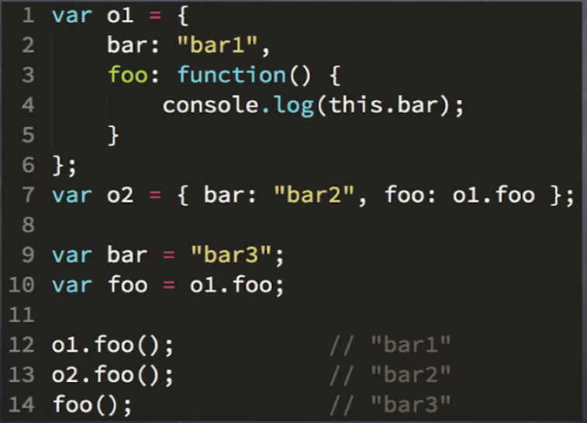

Note: in line 14, foo() is being called without an object therefore, the default binding rule will apply and it will be bound to the global object (in non-strict mode).

**Hard Binding**

Binding a function to a constant ‘this’ using the .bind(obj) call on the function:

const module = {

x: 42,

getX: function() {

return this.x;

}

};

const unboundGetX = module.getX;

console.log(unboundGetX()); // The function gets invoked at the global scope

// expected output: undefined

const boundGetX = unboundGetX.bind(module);

console.log(boundGetX());

// expected output: 42

Warning: if you’re constantly using hard-binding to bind your ‘this’ to your object – that’s a code smell. Maybe you should use lexical binding (without the ‘this’ keyword) instead of using dynamic binding and then working around it!

* setTimeout(myObj.myMethod,…); - the myMethod ‘this’ will be bound to the global object (done under the hood by the setTimeout function).  
  Therefore, if we want it to be bound to the calling object, we need to hard-bind it:  
  setTimeout(myObj.myMethod.bind(myObj),…);

### Global Object

* In the browser, the global object is the window
* In node.js there is a global object that contain all the top-level definitions of node.js
* Every global variable is defined on the global object as property of this object.

### New Keyword

The new keyword doesn’t instantiate a new class object like in other languages.

Instead, it transform any function it is put in front of to a constructor call. Which means:

1. A brand new empty object is created
2. This object get linked to a different object (to **the prototype of the constructor function**).   
   This linkage is called [[Prototype]] or [[P]] linkage and defined the prototype hierarchy.
3. Call the function with ‘this’ bound to the new object.
4. If that function doesn’t return anything, it will return the ‘this’ (i.e. the reference to the object)

### Prototypes

The protypes is the dynamic scope hierarchy that works in execution time (and context) using the ‘this’ and the ‘new’ keywords.

* Each JS **object** has an automatic private property called **[[prototype]]** or **__proto__**.
  + It points to the prototype-object that this object is connected to.
  + The prototype object looks like:  
    null 🡨 object.[[prototype]] <- any other object in JS …
  + can be accessed using:  
    myObj.__proto__   
    Object.getPrototypeOf(myObj)  
    Object.setPrototypeOf(myObj)
* Every **function** in JS has a .**prototype** property which instead specifies the [[Prototype]] to be assigned to all *instances* of objects created by the given function when used as a constructor.

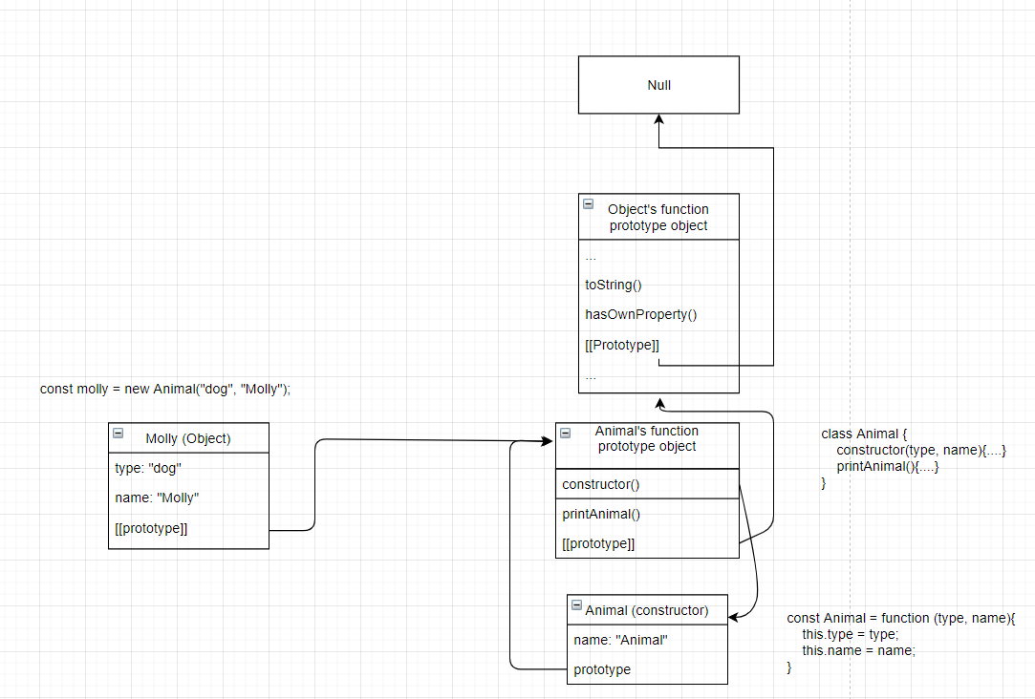

* 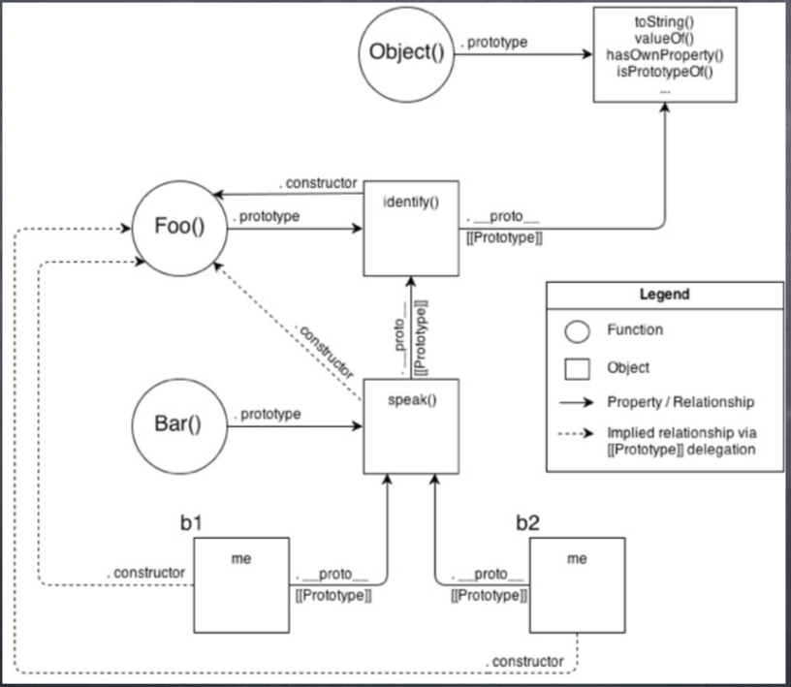

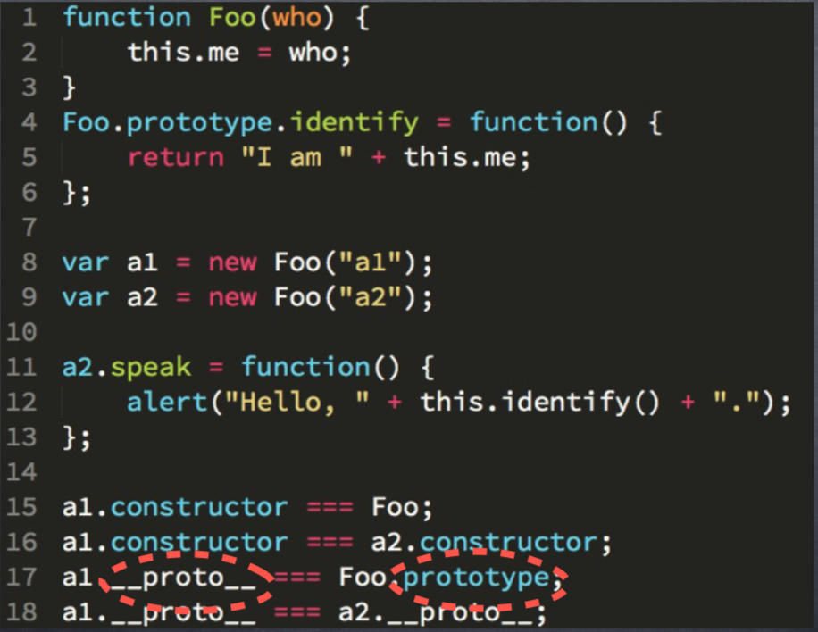

Line 1

|  |  |
| --- | --- |
| Line | Description |
| Before line 1 | Global function Object exist and it has a .prototype property that point to a global prototype object. This global object contains all the global Object functions we know like .toString() etc. |
| 1 | Foo function is created with .**prototype** pointing or a prototype object and Foo.prototype has a property **.constructor** which points to Foo and it is linked **[[P]]** to the global prototype object. Note: .constructor doesn’t mean an actual constructor like in other OO languages. This is just a name |
| 4 | Foo.prototype gets a new function .identify |
| 8 | Object a1 is created. It is linked ([[P]]) to Foo.prototype and it has an additional property .me created on it (not! on the prototype)  Note: it doesn’t have a property .constructor. However, if one isn’t found, it will search for it in the prototype hierarchy. |
| 17 | a1.__proto__ pronounced Dunder-Proto is actually a public property that access the [[P]] for the object (i.e. the prototype object that a1 is linked to). |
|  | a1.identify(); will not find .identify on a1 so it will traverse over the [[P]] hierarchy. It will find it in a1.__proto__ and will execute it. |

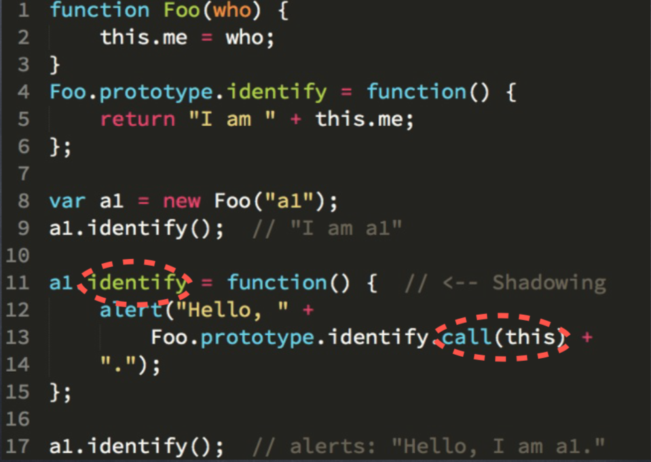

line 11 – declaration of a variable – this variable will be created on a1 and therefore, will shadow (override) the definition of a1.__prototype__.identify in the a1’s prototype.

Note: shadowing is problematic in JS since in order to actually invoke the prototype’s function, you will need to do hacky things. A better solution will be to call a1.identify something else and then be able to refer to both the a1 version and the a1.__prototype__ version easily:

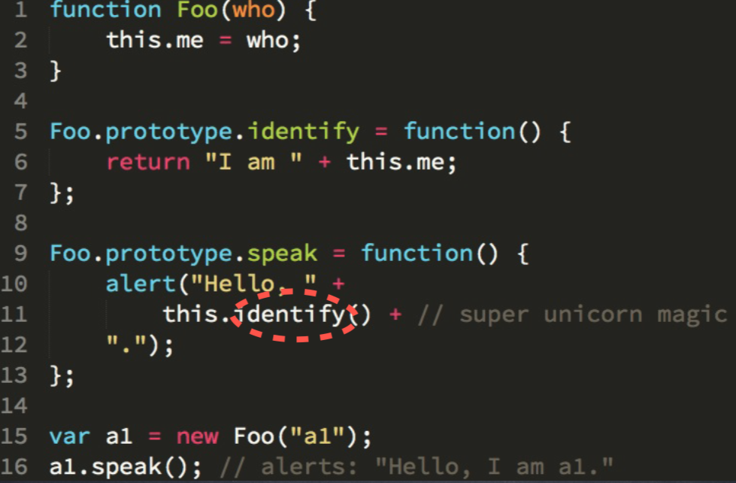

### Lexical vs Dynamic Scopes

* **Lexical scope** – defined during compilation time. Built according to where variables and functions are declared.  
  The root object in the lexical scope is the **global object**.
* **Dynamic scope** – the scope of where and how the functions are being called. This works with the this, new and protypes (see respective sections above)  
  The root object in the dynamic scope is **Object.prototype**
* Note: you can’t switch between the two scopes.

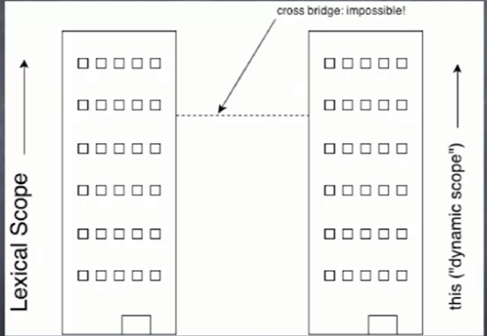

**Rule of thumb:**

* If your code use the ‘this’ keywork but all/most your calling code is using hard-binding to work around the dynamic ‘this’ binding – this is a code smell that you probably want to use a module with closure with lexical scoping instead of the ‘this’ dynamic scoping.

### Object Creation Patterns

Object creation in JS is always done by calling a constructor via the new keyword or Object.create() call

A construction makes an object **linked to** its own **prototype**.

#### Constructor:

You can create an object by defining its constructor:

function Bird() {  
  this.name = "Albert";  
  this.color = "blue";  
  this.numLegs = 2;  
}

let bird = **new** Bird();

When the ‘new’ is called:

1. it creates a new empty ‘Bird’ object
2. Link this object to Bird.prototype ([[P]] hierarchy)
3. ‘this’ is being bound to the new object.
4. Bird() is being called with ‘this’ bound to the new object and it returns the reference to the new object.

#### Object.Create

Object.create(proto) - does the first two steps of creating with ‘new’:

1. A brand new empty object is created
2. This object get linked to proto as the prototype of the object.   
   This linkage is called [[Prototype]] or [[P]] linkage and defined the prototype hierarchy.

Steps 3 and 4 (calling the function and returning the reference) are not done.

### Objects Linked to Other Objects (OLOO)

### Inheritance and Prototypes

* Each JS object has a **prototype property,** which makes inheritance possible in js.
* We put all the **methods** and **parameters** that we want other objects to inherit in the object’s prototype.
* The constructor’s prototype property is **NOT** the prototype of the Constructor itself; it’s the prototype of **ALL** instances that are created through it.
* When a certain method (or property) is called, the search started in the object itself, and if it cannot be found, the search moves on the object’s prototype. This continue through the inheritance chain until the method/property is found in the **prototype chain**.

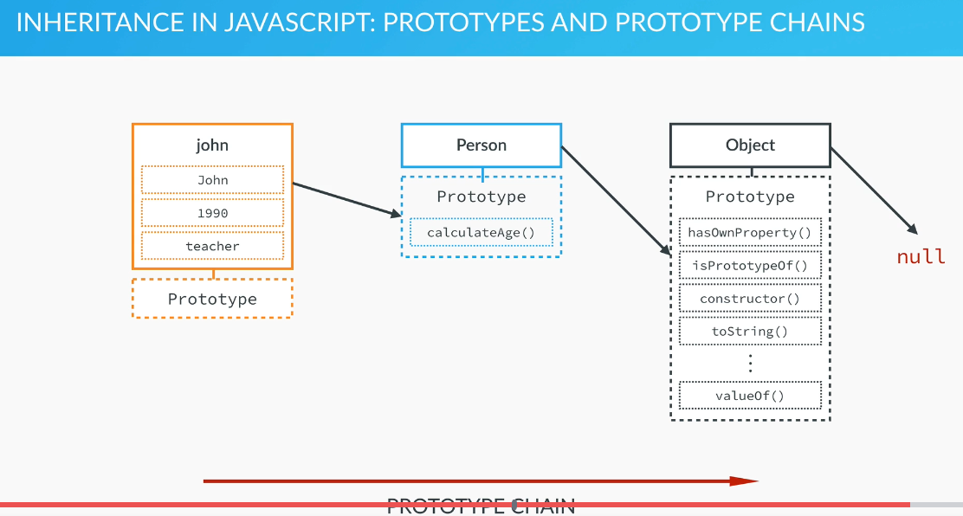

To use the prototype to define parameters and methods:

// If we define the functions as part of the PROTOTYPE, we define it only once for every object's prototypes and all the objects we create

// from it will be able to access and use it without having to duplicate

// the code in all of them:

Person.*prototype*.getJob =

function() {

    console.log(`${*this*.name} is a ${*this*.job}`);

    return *this*.job;

}

Note: if would define the function as part of the constructor:

var Person = function(name, yearOfBirth, job) {

*this*.name = name;

*this*.yearOfBirth = yearOfBirth;

*this*.job = job;

*this*.calculateAge = function() {

        var thisYear = new Date().getFullYear();

        return (thisYear - *this*.yearOfBirth);

    }

}

We will actually cause it to be duplicated for every object that gets created using this constructor, causing **a lot of duplication!**

* When we define a parameter in an object’s prototype, it too is inherited by all the objects that are created from the constructor and they all get the same **default** value.   
  Note: after they get the default value, they can change it and it will save a local parameter on the object itself (not on the prototype) with the same name that will hide the prototype’s parameter. The change will only effect their own object and not other objects that inherit from the same prototype. For example:

Person.*prototype*.lastName = 'Smith';

console.log(john.lastName); // Smith

john.lastName = 'Short';

console.log(john.lastName); // Short

console.log(jane.lastName); // Smith

console.info(john);

// john now have a property: lastName: ‘Short’ and

// also, in its Person.prototype, a property:

// lastName: ‘Smith’

##### Object keys:

Object’s keys can be strings, literals (strings without the quotation marks), numbers.

Note: in any case, JS will typecast them into string.

##### Object notation

Can use either . or [] to access object’s properties.

The [] notation can allow us to access the object’s fields dynamically, depending on the value in the variable.

##### Properties

* + - Own properties – these are the regular properties that are defined per object (i.e. this.property). Like normal C++ member variables.
    - Prototype properties – like C++ static member variables – the same properties are shared between all the objects of this type. This is not true!! When I ran a test, I saw that if I change the prototype property on one object, it doesn’t change it on different objects!! I think that instead, each object receives the prototype’s default value but if you later change it, your change it locally in each object.  
      This is implemented in javascript by having the prototype be actually an object that is shared among all the instances of the class.  
      Bird.**prototype**.numLegs = 2;

You can also add a whole bunch of properties to an already existing object (i.e. constructor):

function Dog(name) {  
 this.name = name;   
}

Dog.prototype = {  
 constructor: Dog,  
 numOfLegs: 4,  
 eat() {…},  
 …   
};

Note: when setting the prototype to a new object, you must re-define the constructor in the prototype (see above in red), otherwise, it will be erased!!

* If the object has only prototype properties without any own properties, you can also define a new object of this type like this:  
  let myDogo = Object.create(Dog.prototype);  
  Note: this method will only initialize the prototype properties. All the member properties will remain undefined!!.
* Inheritance with objects:   
  **NOTE:** in ES6 and up you should use proper classes instead!!  
  Bird.prototype = Object.create(Animal.prototype);  
  Bird.prototype.constructor = Bird;

Now you can add additional properties and functions specific to the inherited object:  
Bird.prototype.myFunc = function() {…}

##### Functions

* + - **hasOwnProperty**(propname) – does the property exist in the object itself? Not: properties that are defined in the object’s prototype will return false here.
    - **Instanceof** – is the object an instance of the constructor:  
      if( bird instanceof Bird)…
    - **JSON.stringify**(object) – will print all the object’s fields and values for debugging.
    - **console.info**(object) – will print the object in a format that allows inspecting it’s internal structure.

##### Mixin

As you have seen, behavior is shared through inheritance. However, there are cases when inheritance is not the best solution. Inheritance does not work well for unrelated objects like Bird and Airplane. They can both fly, but a Bird is not a type of Airplane and vice versa.

For unrelated objects, it's better to use mixins. A mixin allows other objects to use a collection of functions.

let flyMixin = function(obj) {  
  obj.fly = function() {  
    console.log("Flying, wooosh!");  
  }  
};

**The flyMixin takes any object and gives it the fly method**.

let bird = {  
  name: "Donald",  
  numLegs: 2  
};  
  
let plane = {  
  model: "777",  
  numPassengers: 524  
};  
  
flyMixin(bird);  
flyMixin(plane);

Here bird and plane are passed into flyMixin, which then assigns the fly function to each object. Now bird and plane can both fly:

bird.fly(); // prints "Flying, wooosh!"  
plane.fly(); // prints "Flying, wooosh!"

Note how the mixin allows for the same fly method to be reused by unrelated objects bird and plane.

#### Closure

The simplest way to **make properties private** is by creating a variable within the constructor function. This changes the scope of that variable to be within the constructor function versus available globally. This way, the property can only be accessed and changed by methods also within the constructor function.

function Bird() {  
  let hatchedEgg = 10; // private property  
  
  this.getHatchedEggCount = function() { // publicly available method that a bird object can use  
    return hatchedEgg;  
  };  
}  
let ducky = new Bird();  
ducky.getHatchedEggCount(); // returns 10

Here getHachedEggCount is a privileged method, because it has access to the private variable hatchedEgg. This is possible because hatchedEgg is declared in the same context as getHachedEggCount. In JavaScript, a function always has access to the context in which it was created. This is called closure

## Classes

JS doesn’t support full-fledged class-based implementation of object-oriented paradigm like in C++ or python.

Instead, it has a syntax to allow re-using an object definition to instantiate new objects.

### ES5 and Below

var SpaceShuttle = function(targetPlanet){  
  this.targetPlanet = targetPlanet;  
 this.count = 0;  
}

**SpaceShuttle.prototype.countMyCalls** = function() {  
 this.count++;  
}

var zeus = **new** SpaceShuttle('Jupiter');

### ES6

class SpaceShuttle {  
 constructor(targetPlanet){  
 this.targetPlanet = targetPlanet;  
 this.count = 0;  
  
 // Note: for each function that you allow calling from   
 // outside (e.g. React callbacks) – you must bind the   
 // function to this whenever the constructor is called:  
 **this.countMyCalls = this.countMyCalls.bind(this);**

}

countMyCalls() {  
 this.count++;  
 }

// another option will be, using babel class-properties:  
 // this syntax will bind the method automatically to the   
 // class so we won’t have to bind it in the constructor.  
 countMyCalls = () {…}

}

const zeus = new SpaceShuttle('Jupiter');

#### This

Even though it appears this refers to the object where it is defined, it is not until an object invokes the this Function that this is actually assigned a value. And the value it is assigned is based **exclusively** on the **object** that invokes the this Function. this has the value of the invoking object in most circumstances. However, there are a few scenarios where this does not have the value of the invoking object:

1. When **passing the function through a Callback**:

// We have a simple object with a clickHandler method  
// that we want to use when a button on the page is   
// clicked

var user = {

count:0,

clickHandler:function (event) {  
 count += 1;  
 console.log(`Current count is: ${this.count}`);  
 }  
};

// The button is wrapped inside a jQuery $ wrapper,   
// so it is now a jQuery object  
// And the output will be undefined because there is  
// no data property on the button object

$ ("button").click (user.clickHandler);   
// Cannot read property count of undefined

**How to fix:**

Instead of this line:

$("button").click(user.clickHandler);

We have to **bind** the clickHandler method to the user object like this:

$("button").click(user.clickHandler.bind(user)); // count

Note: a better solution will be to use closure instead of the ‘this’ pointer

1. When **passing to an inner method (closure):**

var user = {  
 tournament:"The Masters",  
 data :[ {name:"T. Woods", age:37},  
 {name:"P. Mickelson", age:43}],

clickHandler:function () {  
 // the use of this.data here is fine, because   
 // "this" refers to the user object, and data is   
 // a property on the user object.

this.data.forEach (function (person) {

// But here inside the anonymous function   
 // (that we pass to the forEach method),   
 // "this" no longer refers to the user object.  
 // This inner function cannot access the outer   
 // function's "this"

console.log("What is This referring to? " + this);   
 //[object Window]

console.log(person.name + " is playing at " +  
 this.tournament);

// T. Woods is playing at undefined  
 // P. Mickelson is playing at undefined

})  
 }  
};

user.clickHandler(); // What is "this" referring to? [object Window]

**How to fix:**

**Initialize a local variable to this before calling the anonymous function:**

var user = {  
 tournament:"The Masters",  
 data :[ {name:"T. Woods", age:37},  
 {name:"P. Mickelson", age:43} ] ,

clickHandler:function () {

**var theUserObj = this;**  
 this.data.forEach(function (person) {

console.log (person.name + " is playing at " +   
 theUserObj.tournament);

});  
 }  
};

1. **When assigning the method to a variable:**

var information = {  
 count: 0,  
 showCounter:function (event) {  
 console.log (`Current Counter is: ${this.count}`);  
 }  
};

// Assign the user.showData to a variable -   
// will cause the 'this' to be undefined in showUserCounter:

var showUserCounter = information.showCounter;  
showUserCounter(); // Current Counter is **undefined**

**how to fix:**

bind the new function to the object:

var fixedUserCounter = information.showCounter.**bind(information)**;

fixedUserCounter(); // Current Counter is: 0

##### 

#### Static Member Variables and Methods

called without [instantiating](https://developer.mozilla.org/en-US/docs/Web/JavaScript/Introduction_to_Object-Oriented_JavaScript#The_object_(class_instance)) their class and **cannot** be called through a class instance.

Static variables are often used to create caches, fixed-configuration etc:

class Point {  
 …  
 **static** displayName = “Point”;  
 …  
}  
…  
const p1 = new Point();  
p1.displayName; // undefined  
Point.displayName; // “Point”

Static methods are often used to create utility functions for an application.”:

class Point {

…

**static** distance(a, b) {  
 const dx = a.x - b.x;  
 const dy = a.y - b.y;  
 return Math.hypot(dx, dy);  
 }

}

#### Setters & Getters

By convention - _ mark private member variable (although it’s not really private…)

class Book {  
  constructor(author) {  
    this.**_**author = author;  
  }  
  // getter  
  **get writer**(){  
    return this._author;  
  }  
  // setter  
  **set writer**(updatedAuthor){  
    this._author = updatedAuthor;  
  }  
}  
const lol = new Book('anonymous');  
console.log(lol.writer);  // anonymous  
lol.**writer** = 'wut';  
console.log(lol.writer);  // wut

# Variables

Declaring:

var ourVariable; // ES5 and bellow. Should not use  
 // anymore!

Use **let** instead of var to declare variables! This will make sure that you can’t overwrite existing variables by mistake!

Use: **“use strict”;** to enable strict mode that will catch common coding mistakes and “unsafe” actions!

* Variable names can be made up of numbers, letters, and $ or _, but may not contain spaces or start with a number.
* When declaring a new variable, its initial value is undefined
* If you do a mathematical operation on an undefined variable your result will be NaN which means *"Not a Number"*.
* If you concatenate a string with an undefined variable, you will get a literal *string* of "undefined".
* **const** <var> = <val> - define a const variable with the same advantages as let.  
  should be defined with ALL_CAPS!
  + Note: if you define an array or object as const, you will still be able to change it’s internal parameters. You just won’t be able to change it to point to a different array/object.
  + To prevent change the data, you can use **Object.freeze(obj)** function instead.
  + Best practice: unless you know that you’ll need to change the variable, **always define it as const**. This way to prevent accidental change!

# Statements vs Expressions

* Expressions return an immediate result for example:

2+5;

myFunc(7);

…etc

* Statement is code that defines something. For example:

Function myFunc {return 8;}

Or

If(true) {console.log(‘true’);}

Statements return ‘**undefined’**

# Useful Functions

* setInterval(() => ++myVariable, 500); - will add 1 to myVariable every 500 ms (timer)

# Functions

* Primitives are passed by value
* Reference types are passed by reference

**function** **funcName**(var1, var2) {

…

return result;

}

Is equal to:

let **funcName = function**(var1, var2) {…}

If the function doesn't have a return statement, when you call it, the function processes the inner code but the returned value is undefined.

##### Gotchas

* Js doesn’t enforce that the calling code passes the correct number of variables to the function.
* eval() method – very problematic (see Scoping). Recommendation: never use it unless there is absolutely no other option. This is also true for calling setTimeout with the string syntax which actually uses the eval mechanism.
  + with() keyword – also create an additional scope and prevent compiler optimisations. In strict mode, it’s not allowed anymore.

##### Default Arguments

* JS support default arguments in functions.
* Unlike python, it re-define the default argument every time the function is called and

##### The Rest Operator (args)

…args – can accept a variable number of arguments:

function howMany(...args) {  
  return "You have passed " + args.length + " arguments.";  
}

##### Static Variables

Since functions in javascript are objects, you can define properties on them that will act as static variables. For example:

function someFunction(arg) {  
 if( **someFunction.staticCounter** == undefined) {  
 someFunction.staticCounter = 0;  
 }  
 else {  
 someFunction.staticCounter++;  
 }  
}

## Function Types

* **Named Function declaration**: function functionName(…){..}  
  is usually better than
* **Named function expression**: var myFunc = function functionName(…){…};  
  which is usually better than
* Arrow function: (…) => val

## Function Expressions

* Function declaration:   
  **function** functionName(…) {  
   …  
  }
* Function expression – every function definition that does not have the ‘function’ keyword as the 1st word in the expression:  
  var foo = function bar() {  
   …  
  }
* Don’t use anonymous function expressions. Instead, always try to use a named function expression (i.e. include the ‘bar’ in the example above);
  + It allows you to reference the function from within it.
  + Allows you to debug your code in production
  + Self-documenting your code.

##### The Spread (unpack) Operator

When we need to unpack a string/array to individual characters/values in order to pass them as arguments to a function.

Example:

function sum(x, y, z) {  
 return x + y + z;  
}

const numbers = [1, 2, 3];

console.log(sum(...numbers));  
// expected output: 6

Another example:

const arr1 = ['JAN', 'FEB', 'MAR', 'APR', 'MAY'];  
const arr2 = [‘JUNE’, ‘JULY’];  
let combineArrays = [...arr1, ...arr2];

let myArray = [1, 2, 3];

console.log(myArray);           // [1, 2, 3]

functionWithThreeParams(myArray);   // [1, 2, 3] , undefined , undefined

console.log(...myArray);            // 1 2 3

functionWithThreeParams(...myArray);    // 1, 2 , 3

##### Destructuring Assignment

Unpacking objects into variables:

var voxel = {x: 3.6, y: 7.4, z: 6.54 };  
var x = voxel.x; // x = 3.6  
var y = voxel.y; // y = 7.4  
var z = voxel.z; // z = 6.54

Here's the same assignment statement with ES6 destructuring syntax:

const { x, y, z } = voxel; // x = 3.6, y = 7.4, z = 6.54

If instead you want to store the values of voxel.x into a, voxel.y into b, and voxel.z into c, you have that freedom as well.

const { x : a, y : b, z : c } = voxel;   
// a = 3.6, b = 7.4, c = 6.54

when we want to assign values as part of the code, we will enclose the destructing assignment in parentheses:

({x, y, z} = voxel);

**With Default values:**

({x, y, z, n**=15**} = voxel);

**Using different variable names:**

|  |
| --- |
| const person = {  name: ‘John Doe’,  country: ‘Canada’ };  // Assign default value of 25 to years  // if age key is undefined ({name: fullname, country: place, age: years = 25} = person; // here: fullname, place, years are new variable names and  // years has a default value of 25. |

**Nested Object Destructuring:**

const student = {  
 name: 'John Doe',  
 age: 16,  
 scores: {  
 maths: 74,  
 english: 63  
 }  
};

// We define 3 local variables: name, maths, science  
const { name, scores: {maths, science = 50} } = student;

**Skipping**

Deconstructing objects doesn’t require skipping like in arrays since you can explicitly only set the variables you care about.

**Array Destructuring**

**:**

const rgb = [255, 200, 0];

// Array Destructuring  
const [red, green, blue] = rgb;

// Array Destructuring assignment –   
//doesn’t require the parentheses:  
[red, green] = rgb;  
  
// Skip the first two items:  
[,,blue] = rgb;

**Nested Array Destructuring:**

const color = ['#FF00FF', [255, 0, 255], 'rgb(255, 0, 255)'];

// Use nested destructuring to assign red, green and blue  
const [hex, [red, green, blue]] = color;

console.log(hex, red, green, blue); // #FF00FF 255 0 255

**Swapping variables:**

[width, height] = [height, width];

**Rest Items**

You can use the rest operator to assign the rest of the items:

const rainbow = ['red', 'orange', 'yellow', 'green', 'blue', 'indigo', 'violet'];

// Assign the first and third items to red and yellow  
// Assign the remaining items to otherColors variable  
// using the spread operator(...)

const [red,, yellow, **...otherColors**] = rainbow;

console.log(otherColors); // ['green', 'blue', 'indigo', 'violet']

**Cloning Arrays**

const [...rainbowClone] = rainbow;

**Mixed Deconstructing**

const person = {  
 name: 'John Doe',  
 age: 25,  
 location: {  
 country: 'Canada',  
 city: 'Vancouver',  
 coordinates: [49.2827, -123.1207]  
 }  
}

// Observe how mix of object and array destructuring is being used here  
// We are assigning 5 variables: name, country, city, lat, lng

const {name, location: {country, city, coordinates: [lat, lng]}} = person;

console.log(`I am ${name} from ${city}, ${country}. Latitude(${lat}), Longitude(${lng})`);

##### Higher-Order Function (from freeCodeCamp)

A function that returns another function:

function getGreeter() {

return function() {

return 'Hi, Jerome!';

};

}

getGreeter returns a function. To be greeted, call it twice.

getGreeter(); // Returns function

getGreeter()(); // Hi, Jerome!

You can store it in a variable for easier reuse.

const greetJerome = getGreeter();

greetJerome(); // Hi, Jerome!

greetJerome(); // Hi, Jerome!

Instead of hardcoding Jerome, we'll make getGreeter dynamic by accepting one parameter called name.

// We can greet anyone now!

function getGreeter(name) {

return function() {

return `Hi, ${name}!`;

};

}

And use it like so...

const greetJerome = getGreeter('Jerome');

const greetYazeed = getGreeter('Yazeed');

greetJerome(); // Hi, Jerome!

greetYazeed(); // Hi, Yazeed!

**This is closure**: the returned inner function have access to its parent’s variables even after the parent function already finished and its variables cleared. This allows defining private variables.

##### Currying

Closure also allows functions currying. This is when a function is pre-loaded with some values to improve re-use.

For example:

const translate = function(languageObject) {

return function(str) {

return language.translate(str);

}  
}

const translateToFrench = translate(French);

const translateToGerman = translate(German);

translateToFrench(“how are you”);

translateToGerman(“how are you”);

## Immediately Invoked Function Expression (IIFE)

A common pattern in JavaScript is to execute a function as soon as it is declared:

**(**function () {  
  console.log("Chirp, chirp!");  
}**)()**; // this is an anonymous function expression that executes right away  
// Outputs "Chirp, chirp!" immediately

Note that the function has no name and is not stored in a variable. The two parentheses () at the end of the function expression cause it to be immediately executed or invoked. This pattern is known as an immediately invoked function expression or IIFE.

Note: always name your IIFEs. This will make them easier to debug and also is self-documenting. So always prefer:  
**(**function () **myNamedIIFE**{  
  console.log("Chirp, chirp!");  
}**)()**;

### Create a Module Using IIFE

An immediately invoked function expression (IIFE) is often used to group related functionality into a single object or module. For example, an earlier challenge defined two mixins:

function glideMixin(obj) {  
  obj.glide = function() {  
    console.log("Gliding on the water");  
  };  
}  
function flyMixin(obj) {  
  obj.fly = function() {  
    console.log("Flying, wooosh!");  
  };  
}

We can group these mixins into a module as follows:

let motionModule = (function () {  
  return {  
    glideMixin: function (obj) {  
      obj.glide = function() {  
        console.log("Gliding on the water");  
      };  
    },  
    flyMixin: function(obj) {  
      obj.fly = function() {  
        console.log("Flying, wooosh!");  
      };  
    }  
  }  
}) (); // The two parentheses cause the function to be immediately invoked

Note that you have an immediately invoked function expression (IIFE) that returns an object motionModule. This returned object contains all of the mixin behaviors as properties of the object.

The advantage of the module pattern is that all of the motion behaviors can be packaged into a single object that can then be used by other parts of your code. Here is an example using it:

motionModule.glideMixin(duck);  
duck.glide();

## Pure Functions

A pure function in JavaScript is one that **given the same input, will always return the same output without side effects.** Put simply, pure functions only depend on their input arguments.

## Common Functions

* typeof
* Math.random() – return 0<=rand<1;
* Math.floor() – round the number down to its nearest whole number
* parseInt(<string>,<radix>) – convert the string to an int, or return NaN. Radix is the base 2-36.
* console.log(<text>); - print debug information
* console.clear() – clear the console.
* <string>.replace(<old_string>,<new_string>) find and replace string.

## Anonymous Functions

### ES5 and Below

const myFunc = function() {  
  const myVar = "value";  
  return myVar;  
}

### Arrow Functions (in ES6)

const myFunc = (args) => {  
  const myVar = "value";  
  return myVar;  
}

When there is no function body, and only a return value, arrow function syntax allows you to omit the keyword return as well as the brackets surrounding the code. This helps simplify smaller functions into one-line statements:

const myFunc = (args) => "value"

if we pass only one argument, we can remove the parentheses:

const myFunc = arg1 => "value"

**Warning:** arrow functions not matter how short are **just** another form of **anonymous functions**. Therefore, they reduce readability and debugging ability and shouldn’t be used as a rule of thumb!!

## Curried Functions

The arity of a function is the number of arguments it requires. Currying a function means to convert a function of N arity into N functions of arity 1.

In other words, it restructures a function so it takes one argument, then returns another function that takes the next argument, and so on.

Here's an example:

//Un-curried function  
function unCurried(x, y) {  
  return x + y;  
}  
  
//Curried function  
function curried(x) {  
  return function(y) {  
    return x + y;  
  }  
}  
curried(1)(2) // Returns 3

This is useful in your program if you can't supply all the arguments to a function at one time. You can save each function call into a variable, which will hold the returned function reference that takes the next argument when it's available. Here's an example using the curried function in the example above:

// Call a curried function in parts:  
var funcForY = curried(1);  
console.log(funcForY(2)); // Prints 3

### 

## Higher Order Functions

functions that take functions to execute on their input.

Examples are .map, .reduce etc.

## Partial Application

partial application can be described as applying a few arguments to a function at a time and returning another function that is applied to more arguments.

Here's an example:

//Impartial function  
function impartial(x, y, z) {  
  return x + y + z;  
}  
var partialFn = impartial.bind(this, 1, 2);  
partialFn(10); // Returns 13

# Module Pattern

Modules **encapsulate** data and behavior (methods) together. The state (data) of a module is held by its methods **via closure**.

Note: a critical attribute to being a module is the data encapsulation. Without the closure (which allows the data encapsulation), there is no modules, just name-spaces.

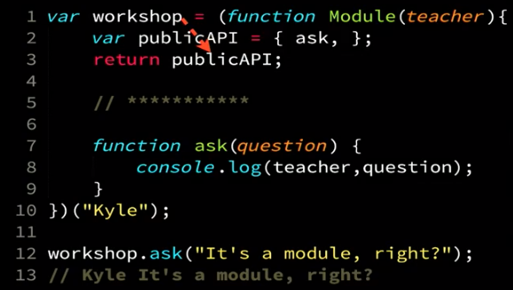

1-10: workshop is assigned publicAPI of Module which is the result of running the Module IFFE ran with the parameter “Kyle”.

Note:

* workshop.teacher is hidden and can’t be accessed from outside. But it’s held by ask() closure and can be accessed by it.
* Workshop.ask() is public since it was returned from the invocation of the Module IIFE
* Writing the module using an IIFE create it as a singleton (only created once). However, this is not a requirement of modules. We can create the module using a regular function declaration. This is called a factory function and is used to create instances of the module (like objects of a class)

## Factory Functions

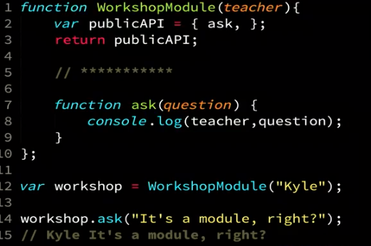

Now we can create different object and initialize them with different parameters:  
var teacher1 = WorkshopModule(“Kyle”);  
var teacher2 = WorkshopModule(“Jane”);  
…

## ES6 Modules

In ES6 – every file is automatically a module and everything within it is private, unless it is exported using the ‘export’ statement.

Notes:

* It’s not possible to have more than 1 module per file. That’s why in order to work with ES6 modules, you have to transpile them in order to combine them into one resource that can be send and loaded into a website. The traspiler actually translate the ES6 module to the original module pattern syntax.
* All ES6 modules are singletons. Meaning, no matter how many times you import them, they only run once. So if you want to allow clients to create multiple instances of your module, you will need to create and export a factory method for this.

### Import

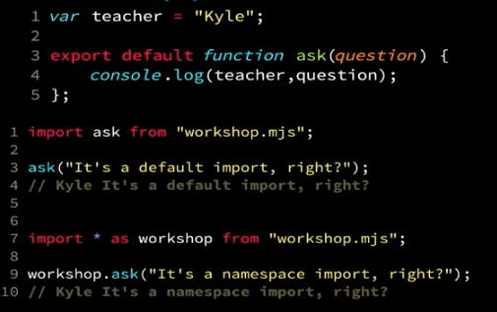

## ES6 Modules and Node.js

* Node.js fully support the module pattern as presented in the previous sections.
* However, its support for ES6 modules is still WIP. Check its status before using it.

# Regular Expression

By default, the regex of JS is greedy e.g. find the longest possible match.

### Test method – on regex

let testStr = "freeCodeCamp";  
let testRegex = /Code/;  
testRegex.test(testStr);  
// Returns true

### Match method – on string

Returns an array with the matched string.

let ourStr = "Regular expressions";  
let ourRegex = /expressions/;  
ourStr.match(ourRegex);  
// Returns ["expressions"]

### Create a Regular Expression

To create a regular expression from a string:  
new RegExp(string, flags) where flags are g or i. For example:  
myRegex = new RegExp('god', 'i');

### JS Regex Patterns

* Find string1 or string 2: /string1**|**string2/
* **Flags:**  
  You can add flags for the regex after the closing / of the regex. For example: the ignore case flag /i:
  + Ignore case in the regex: /regex/**i**
  + Find all patterns in string: /regex/**g**
* **Lookaheads**will check for patterns **starting immediately in the current position** **without consuming them** (so after the search, the regex engine is still in the same position as before). This is useful for checking for two or more conditions on the same string. Since lookahead doesn’t consume the string, you can test for different conditions on the same string in the same regex. This is useful for checking validity conditions or for password checks:
  + **Positive lookahead: (?=**<regexp>**)** – will match if found the <regexp>
  + **Negative lookahead (?!**<regexp>**)** – will match if could not find the <regexp>
  + Example: check that a password have between 3-6 characters and at least one number:

let checkPass = /(?=\w{3,6})(?=\d)/;

* **Capture groups:**
  + In the regex: define with (<exp>) and   
     re-use with **\**<group num from 1>
  + In the match group (after the match): use with **$**<group numb from 1>

## $

$(window).bind('load', function() {

$('img.protect').protectImage();

});

There's nothing mysterious about the use of $ in JavaScript. $ is simply a valid JavaScript identifier.

JavaScript allows upper and lower letters, numbers, and $ and _. The $ was intended to be used for machine-generated variables (such as $0001).

Prototype, jQuery, and most javascript libraries use the $ as the primary base object (or function). Most of them also have a way to relinquish the $ so that it can be used with another library that uses it. In that case you use jQuery instead of $. In fact, $ is just a shortcut for jQuery.

# External Functions

## Web API

* SetTimeout(callbackFunction, seconds) – will put the callbackFunction in the callbackQueue after {x} seconds. Note: this does not mean that the callbackFunction will actually run after {x} seconds – since it will have to wait until the stack is empty and it’s the 1st function in the callback queue before it’s picked up into the stack to run.

# Behind the Scenes

1. After a program leaves a developer's editor, it gets **transpiled** by Babel, then **packed** by Webpack (and perhaps half a dozen other build processes), then it gets delivered in that very different form to a JS engine.
2. JS code always run in a host environment. This can be:
   * Browser – for most client-side applications
   * Node JS Server – for node js code
   * Application – for applications that except js input.
3. The JS Engine in the host execute the JS in the following case:

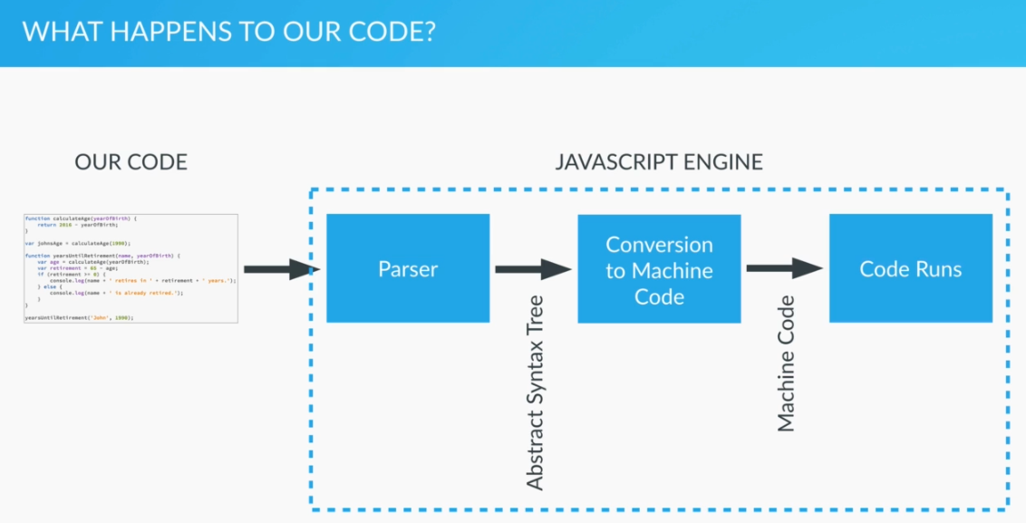

* + There are many different JS engines like the Chrome’s V8 or Mozila’s SpiderMonkey engine.

## Execution Context

The context in which js runs. We can look at it as a box/container/wrapper which stores variables and in which a piece of our code is evaluated and executed.

### Default Execution Context = Global Execution Context

The default execution context is the Global execution context. This includes:

* + All code that is **not inside any function**
  + It’s associated with the **global object**
  + In the browser, that’s the window object.  
    So when we declare a variable outside of any function:  
    let lastName = “Smith”;  
    we actually define it inside the global object (in a browser -> the window, in node.js there is an global object):  
    lasteName === window.lastName; // true

### Function Execution Context

* Whenever we declare a function, it creates a new execution context.
* Each execution context is isolated from the other execution context but it can access it’s containing execution context (e.g. global).

#### Execution Context Stack

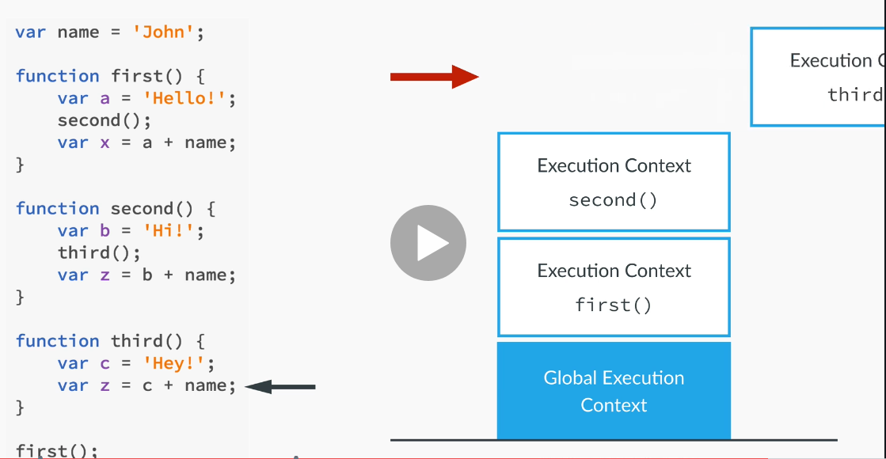

Every time a new execution context is created, it execute the following:

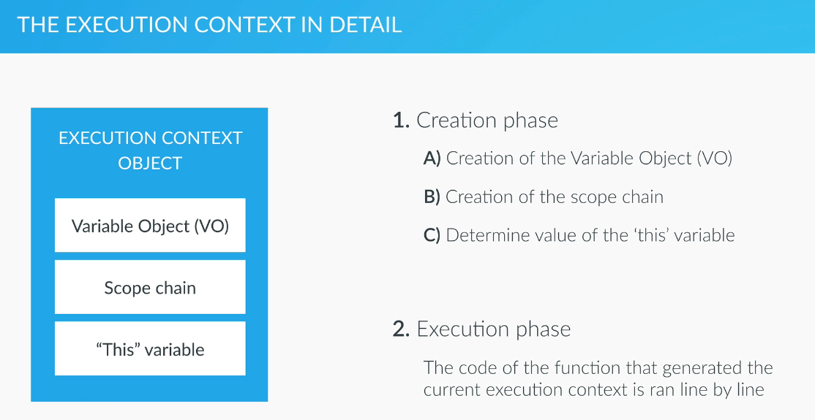

* **Variable Object (VO) creation:**
  + The argument object is created, containing all the arguments that were passed into the function
  + **Hoisting:  
    Note:** the hoisting happens in the creation phase, before the code is executed!
    - Code is scanned for **function declarations**: for each function, a property is created in the Variable Object, **pointing to the function**.
    - Code is scanned for **variable declarations**: for each variable, a property is created in the Variable Object, and **set to undefined**.
* **Creation of scope chain:**
  + Calculate the scope chain (who has access to what) in this execution context.
* **this:**
  + Regular function call: the this keyword points at the global object (the window object, in the browser)
  + Method call: the ‘this’ variable points to **the object that is calling the method**.  
    Note: the **‘this’ is not assigned a value until there is the first call** to an object’s method! Is it not assigned when the object is defined. Only when it actually calls a method!   
    This is because the ‘this’ variable is defined in the execution context of the method and that is created only when the method is being called!

### Event Loops

Excellent Talks:

* Philip Roberts: <https://www.youtube.com/watch?v=8aGhZQkoFbQ>
* Jake Archibald: <https://www.youtube.com/watch?v=cCOL7MC4Pl0>
* JS Code running visualization: <latentflip.com/loupe>

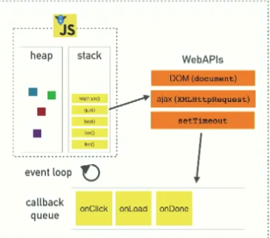

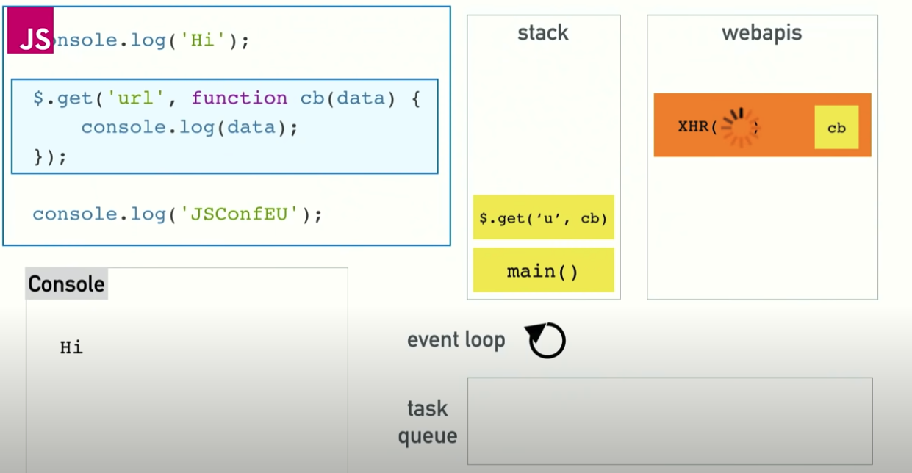

The call stack: javascript is a single-threaded language. This means that it has:  
one call stack that execute one thing at a time.

#### Priority Queues

JS engines (e.g. V8) are single threaded and work with prioritized execution queues. From highest priority to lowest:

* + - 1. Execution Stack - as long as there is code to run in the execution stack , it will run.
      2. Micro-tasks/jobs/Promises Queue - micro-tasks include
         * Promises callbacks
         * Mutation Observer
      3. Rendering Loop - should run every 10ms in order to keep the page responsive. Every 10ms, the (browser?) puts a rendering request in the rendering queue to be serviced to render the page whenever the execution and jobs queues are empty
      4. Callback queue - whenever we call a WebApi with a callback function, the callback will be put into the callback queue to execute once all the above are empty. Example of callbacks:
         * SetTimeout(…)
         * AddEventListener(…)

#### Multithreading:

The WebAPIs are actually calling different threads that run concurrently to the JS runtime (e.g. V8). In Node JS, instead of WebAPIs, C++ code is handling the multi-threading of the server-side calls. In any case, these external APIs take callback functions so once they are finished, they put the callback function call in the callback queue

#### The Main Thread

The **main thread** in the browsers is where the DOM lives and where user interaction happens including rendering. The fact that it’s single threaded means that sync is pretty straight forward. However, slow things (>=200ms) will cause a noticeable degredation in user experience.

#### Event Loop

Whenever JS’s main stack is empty, the JS runtime look at the callback (task) queue and if there is anything there, it will put it in the stack to execute.

* + Note: this is also why we would call setTimeout(callbackFun,**0**) with 0 timeout – this will allow us to defer the callback’s execution until the stack is cleared.
  + Note:

#### Render Queue



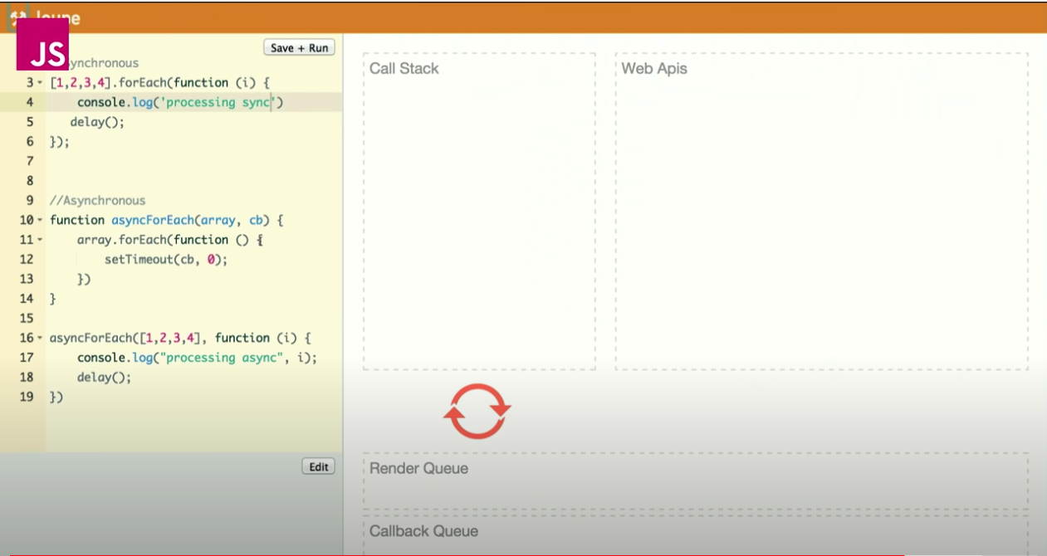

The page (browser tells the JS to do the rendering round) tries to render usually 60 times per second (depends on the browser + screen rate). However, it can’t render while there are calls in the call stack (v8). Therefore, it will put a rendering request in the Render Queue which had higher priority than the Callback Queue so that when the

* + - Call Stack is empty (this means that v8 is not actively working on any task)
    - If there is a rendering request, the page will render (allowing users to interact with it). This will happen even if there are callbacks waiting in the callback queue. Note: if there is a queue of rAFs already in the rendering queue when it executes, they will all get executed (except for ones that are added while the renderer is running)
  + If there is no rendering request in the queue, the next callback function will go on the call stack to execute. Note: the callback (task) stack execute one task at a time. If the other stacks (rendering/microtasks) have tasks in them, they will run after this callback and before the callback queue is checked again.
  + In every rendering round, the renderer do the following in this order:
    - requestAnimationFrame (**rAF**) – user callback that runs as part of the rendering queue. This is a great way to do all the work that’s required to update the visual rendering in a way that is synchronized with the rendering of the page ; see orange below
    - **S**tyle calculations – looking at the CSS and figuring out what style apply to each element; see blue below
    - **L**ayout – where each element need to be on the page; see green below
    - **P**ainting - Doing the actual rendering (pixels on screen)  
      
  + The Microtasks queue will run all the microtasks in it until it’s completely empty. Including all the microtasks that are added to it by currently running microtask. So it can prevent rendering and starve the js callback (tasks) queue :

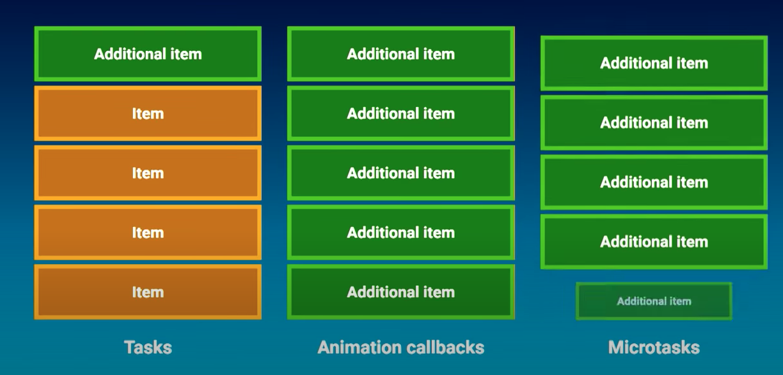

**Notes:**

* This means that all the synchronous changes you make to the DOM in your methods, will run as one unit before the DOM gets rendered for the next time!! So you don’t need to worry about race conditions between two sequential lines of code!
* It also means that all your js code that affect the rendering will run in one block before the page is rendered. So if for example, you want to code some animation that needs to render, make sure that you split is across different rAFs. Otherwise, when the Style Calculation gets called, it only see the final elements values so it won’t see all the stages before it. This is an example of how to render an animation from position 1000 to 500. Note: if you don’t use the double rAFs, it will only render the box in position 500 without any animation:
* 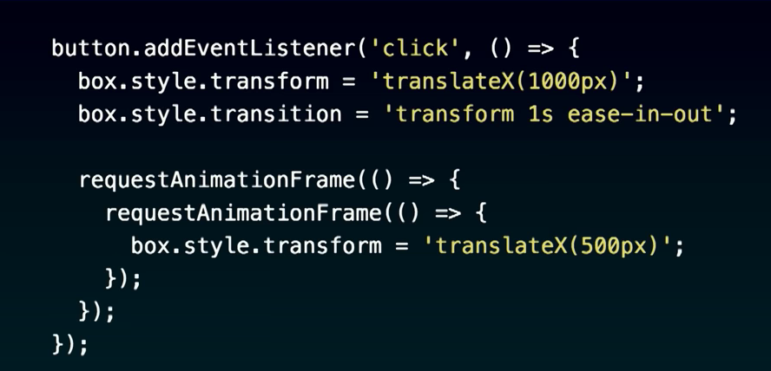  
  
  + In Chrome, you can use the web animation API to avoid this issue but it’s not available in other browsers.
  + In Safari, the rAF is scheduled after the paint instead of at the start of the rendering queue so there is an additional delay for your rendering + Safari will display the state of the system before the rAF ran. That’s a bug and they have a ticket on it.

#### Microtasks Queue

The Microtasks Callbacks Queue runs every time the JS v8 execution stack is empty. Note: it has higher priority than the callback (tasks) queue or the rendering queue!!

It used by:

* + - Promises
    - Mutation Observer

Promise example:

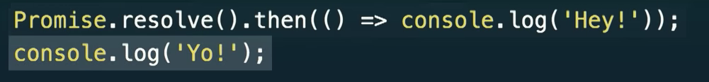

console.log(‘Hey!’); - will be queued in the microtask queue and will run after the console.log(‘Yo!’); has finished running.

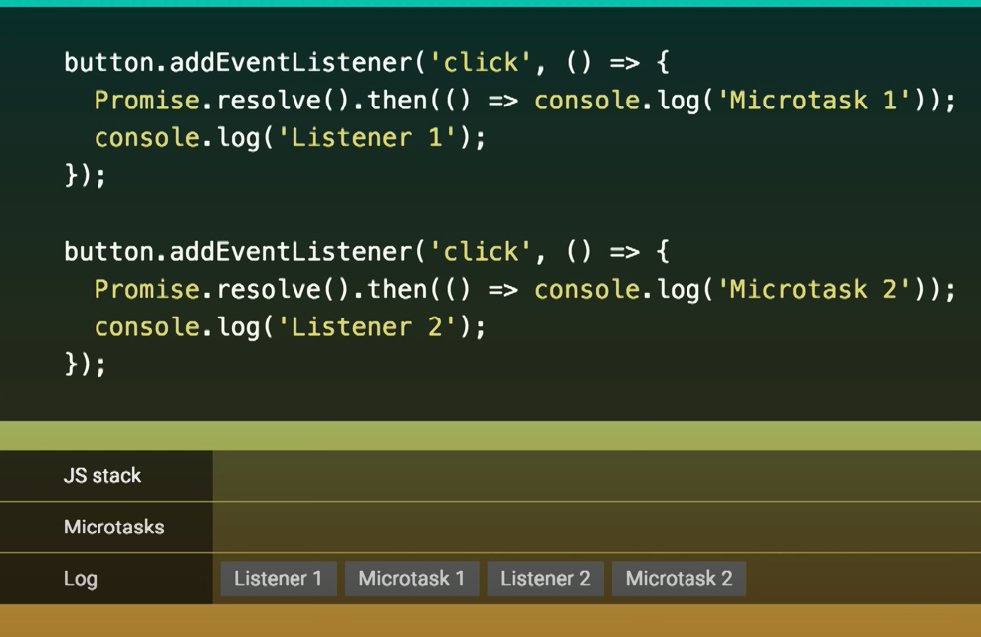

In this example, although both listeners are triggered and put on the callback queue at the same time, since the microtasks have higher priority, the microtask of the 1st listener will run before the 2nd listener is executed!

However, if instead of the user clicking the button, we have js code clicking it, the **button.click(); will only return after all the listeners have finished executing** (!!!) this means that the order of execution will be different:

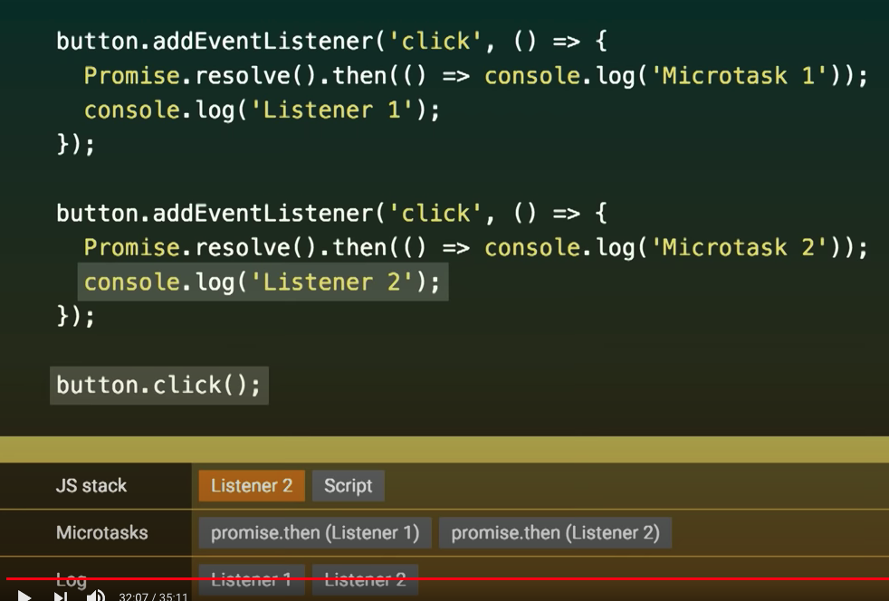

Because ‘Script’ is still executing, the microtasks queue isn’t run and both listeners run before their respective microtasks.

#### Compositor

The compositor is another thread that runs independently from the main thread and is responsible to take the Painted bitmaps from the Rendering Loop (the ‘P’) and actually paint the screen:

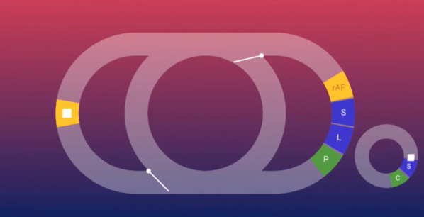

compositor

It can only do simple things like moving or rotating an image.

Transform actions for example can be done by the compositor

top or left actions can’t be done by it.

#### Event Loops



* On modern browsers, different tabs run on different event loops.
* The spec state that pages must share the same event loop if they can gain synchronous access to each other.  
    
  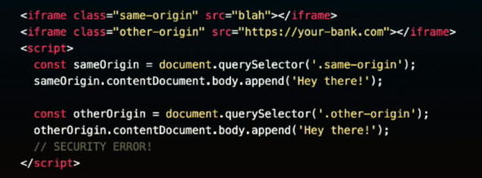
* For hrefs, it’s recommended to add ‘rel=”noopener”’ for both security reasons (isolate the child page from the parent) and in some browser, it will open the child on a different even loop:  
    
  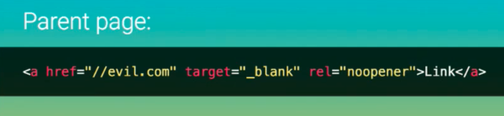

## Scope

* Lexical scope – scopes are defined and processed at compile time. Js is a lexical-scope language.
* eval allows to cheat this mechanism (e.g. eval(“var bar = 42;”); ) but this prevents the js compiler from optimizing your code in non-strict mode. In strict mode, eval will create its own scope and therefore, will not prevent optimization. However, it might be confusing since it will create an additional nested scope.

### Compilation Time

* JS compiler declare all the variables in their respective scopes and remove the ‘var’ keyword from their declaration.
* Note: if there are multiple declaration of the same scope, the compiler will declare it only once and will ignore the repeating declarations (so we can’t overwrite a variable in the same scope). It will however do the assignment (in the execution time by the js engine):  
  function baz(foo) { <- this is where foo will be declared in  
   the ‘baz’ scope  
   var foo = “bam”; <- this declaration will be ignored(foo  
   is already declared). The assignment  
   will still be performed in execution  
   time.  
  }  
  This includes both functions and variables – so you can’t have a variable and a function with the same name since one of them will be overwritten (or disregarded ) by the other one!!
* Note: function expression does not get declared in compilation time since the compiler doesn’t perform its assignment yet. Therefore, it will not exist in the outer scope and will actually only exist within its own scope:  
  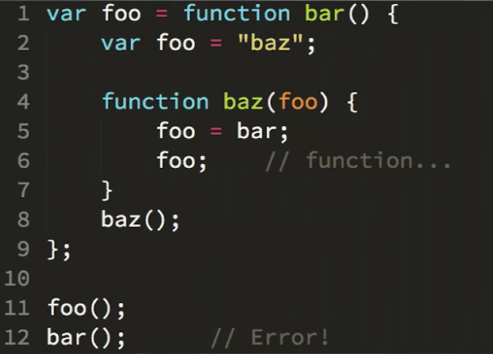

### Execution Time

* For each LHS=RHS assignment, the JS engine asks from the current scope outwards if it has the variables declared. This is being asked for both variables and functions.
* LHS reference: If the global scope doesn’t have the LHS reference and we’re in non-strict mode – it will create them automatically!
  + In strict code, the global scope will return an error ‘undeclared variable’.
* RHS reference: if the global scope doesn’t have it, it will return ‘unknown reference’ error in both strict and un-strict modes.
* Undefined doesn’t mean the same as undeclared in javascript:
  + Undeclared: a variable that wasn’t declared in the scopes hierarchy
  + Undefined: a variable that was declared but not initialized.

JS includes the following scopes (only):

* global
* function level   
  Note: a function that’s defined within another function gets access to the scope of the outer function (lexical scoping)
  + Note: all function parameters are actually declared inside the function’s scope.
* The catch block in try{}catch blocks is its own scope (except in ES6 but in all other versions before/after ES6).
* eval() expression when working in strict mode.

**let** (but not var) also support the following scopes:

* block – will attach the variable to whichever block this declaration appears in.   
  Notes:
  + when declaring a variable with var – any variable used/defined in the block has a global/function scope

So:  
for (**let** i=0 ; I,5 ; i++){…} – i will exist only in the **for-loop scope**  
However,  
for (**var** i=0 ; I,5 ; i++){…} – i will exist in the **outer scope** (function/global)

In JavaScript, a name enters a scope in one of four basic ways:

1. **Language-defined:** All scopes are, by default, given the names this and arguments.
2. **Formal parameters:** Functions can have named formal parameters, which are scoped to the body of that function.
3. **Function declarations:** These are of the form function foo() {}.
4. **Variable declarations:** These take the form var foo;.

Note:

* Variables which are used without the var keyword are automatically created in the global scope. This can create unintended consequences elsewhere in your code or when running a function again. You should always declare your variables with var.

### Block Scope

* {} doesn’t automatically declare a new scope – only if it has a ‘const’ or a ‘let’ declaration in it!
* Best practice: when you have variables that are only required and used for a few lines in the code, you should create a block and declare them at the very opening of the block to make it easier for the developers to see:  
  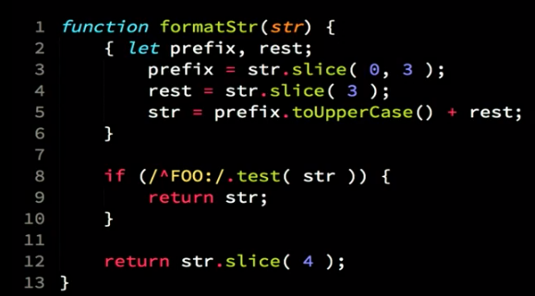

## Hoisting

* **Function** **declarations** and **variable declarations** are always moved (“hoisted”) invisibly to the top of their containing scope by the JavaScript interpreter.
* **Assignment** are **not hoisted**. Even if they are a part of a declaration – the declaration itself (e.g. var x) will be hoisted to the start of the scope but the assignment will stay in it’s original place (x=5;)
* Functions are hoisted before variables!
* **Note:** functions expressions (var myFunc = function(){…}) are not hoisted (since it’s actually assignment and not declaration).
* **Let**: when let is hoisted into its containing scope, it is declared but is not initialized. Not even to ‘undefined’ (like var does). It only gets initialized to ‘undefined’ once the let line is executed (i.e. lexicalBinding evaluated). Therefore, if you try to access the let variable before that, you’ll get TDZ (Temporal Dead Zone) error.
  + In contrast: when var is hoisted, its initialized to ‘undefined’. Therefore, if you try to access it before it’s assigned, you will get ‘undefined’ and not an error.
* **const:** when hoisted, it’s initialized to ‘**uninitialized’** so it will be able to take its final constant value when this line is executed.

**IMPORTANT**: The declaration are **not actually moved around** the code. What is actually happening is that the declarations are marked in the compilation phase, ahead of the execution phase. See Compilation Time for more info. You can think of C header files as doing a manual hoisting.

Function parameters and language-defined names are, obviously, already there. This means that code like this:

var x = 5;

console.log(x); // 5

var y = 10;

is actually interpreted like this:

var x, y; // this line simply declares x and y at the same time.

x = 5;

console.log(x); // 5

y = 10;

Notice how the declaration of y moved to the top of the scope. And also notice how the first line doesn't set a value for neither x nor y. After var x, y; both x and y are undefined. This is because the **assignment** portion of the declarations were **not hoisted**. **Only the name is hoisted**.

**This is also true for functions**:

* When declaring a function as variable:

example2();

var example2 = function() {

console.log("Ran the example");

}

Is equal to:

var example2;

example2();

example2 = function() { => will return an errors.

console.log("Ran the example");

}

* When declaring a function as a function:

example2();

function example2() {

console.log("Ran the example");

}

Is equal to:

var example2;

example2 = function() {

console.log("Ran the example");

}

example2();

## Closure

Closure is when a function “**remembers**” and can access its **full** **lexical scope** even when the function is executed outside that lexical scope.

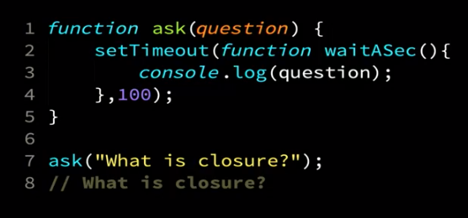

Notes:

* + - You close over your full lexical scop – this means that you have access to the whole hierarchy of scopes you had during compilation time, not just to your enclosing function!  
        
      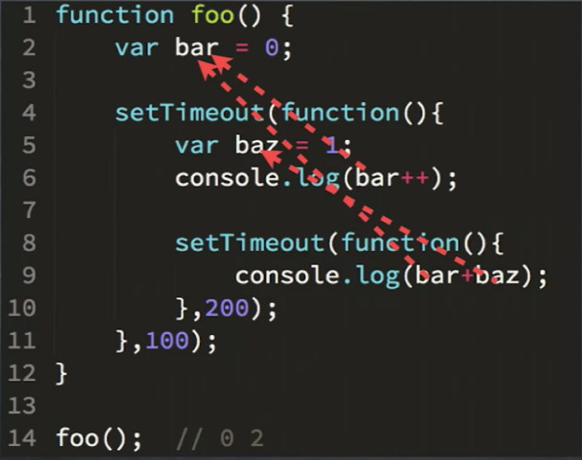
    - You do not close over a specific value! Instead, you close over a variable. So when your function run, it will read the variable at that time.

For example:

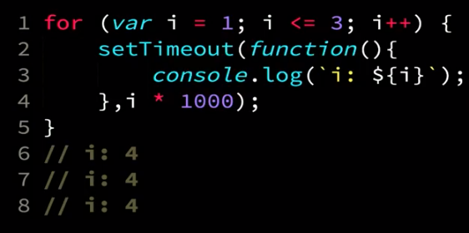

To solve this, create a new variable on every iteration:

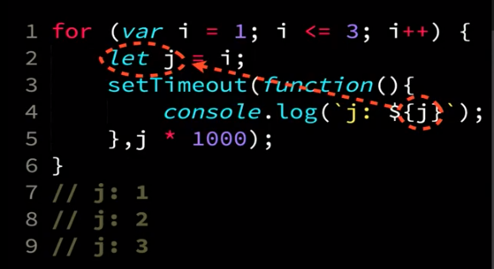

The following works since in it actually create a new **let** i; declaration within each loop and js wires it up so it re-binds the i variable in each iteration. So although it looks like the same variable, it actually contain 3 different variables:

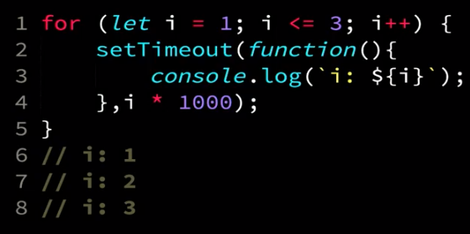

An old solution for this (pre-ES6) was to create a IIFY inside the for loop to do the exact same thing. In this example (below), a new i is declared in the context of the IIFE function every time it’s called and this is the i that is referenced in the setTimeout function call:  
  
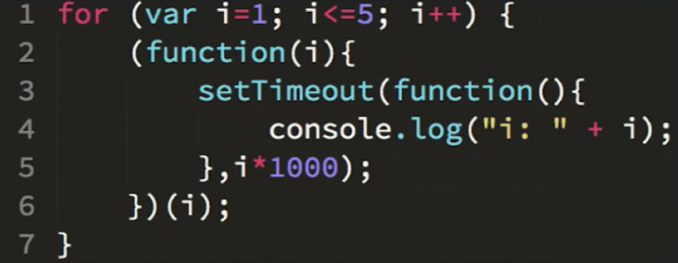

## Global Scope Issue

All the variables declared inside js files are considered to be **part of the global scope**. This causes a lot of problems with variables in different files overwriting each other and resulting in a lot of weirdness….

In order to work around this, it is common to wrap each file with an anonymous function that execute immediately:

**(function () {**

// all the file’s contents…

**})();**

This prevents the variables defined in this file (i.e. function) from leaking into the global scope.

When using JQuery, there is a better solution using the $(document).ready function call that both supply the function-scope and make sure that the script will only run after the html document is ready. See JQuery for more details.

# Program Flow

## Conditions and Loops

JS supports if-else statements, for, while loops like C++ (syntax).

In addition, it supports:

* **for..of:**

**for**( let user **of** users){

user.doSomething();

}

Creates a loop iterating over **any** [iterable objects](https://developer.mozilla.org/en-US/docs/Web/JavaScript/Reference/Iteration_protocols#The_iterable_protocol), including: built-in [String](https://developer.mozilla.org/en-US/docs/Web/JavaScript/Reference/Global_Objects/String), [Array](https://developer.mozilla.org/en-US/docs/Web/JavaScript/Reference/Global_Objects/Array), Array-like objects (e.g., [arguments](https://developer.mozilla.org/en-US/docs/Web/JavaScript/Reference/Functions/arguments) or [NodeList](https://developer.mozilla.org/en-US/docs/Web/API/NodeList" \o "NodeList objects are collections of nodes, usually returned by properties such as Node.childNodes and methods such as document.querySelectorAll().)), [TypedArray](https://developer.mozilla.org/en-US/docs/Web/JavaScript/Reference/Global_Objects/TypedArray), [Map](https://developer.mozilla.org/en-US/docs/Web/JavaScript/Reference/Global_Objects/Map), [Set](https://developer.mozilla.org/en-US/docs/Web/JavaScript/Reference/Global_Objects/Set), and user-defined iterables. It invokes a custom iteration hook with statements to be executed for the value of each distinct property of the object.

*for(let* ***i*** *= 0 ;* ***i****<****stores****.length ;* ***i****++) {*

…

}

* for..in – only for enumerable, non-Symbol properties like properties of objects:

**for**( let key **in** users){

if(users.hasOwnProperty(key)) {   
 users[key].doSomething();   
}

}

**Note**:

* + for-in **return the keys/indexes** of the object/array and not the data itself!!
  + It is usually necessary to test object.hasOwnProperty(variable) to determine whether the property name is truly a member of the object or was found instead on the prototype chain.
* In order for JavaScript to compare two different data types (for example, numbers and strings), it must convert one type to another. This is known as "Type Coercion".
* **Strict equality** (**===**) is the counterpart to the equality operator (==). However, unlike the equality operator, which attempts to convert both values being compared to a common type, the strict equality operator does not perform a type conversion. Strict inequality (!==) is the opposite of ===.
* **Switch** statements is like in C. It uses the strict equality to compare. So if(val===value) is qual to switch(val){ case value:….}
* **if-else** – the same as in C++
* **while** , **for** , **do-while** loops – the same as in C++.
* **Conditional operator (ternary)** – the same as in C++.

## Evaluators

***Never* use ==. It's a frequent source of bugs.**

**Strict equality (**===**) vs Loose equality (**==**)**

When you use three equal signs, ===, no type conversion is done prior to the comparison. If the values are different types, for example, a String and a Number, they can't ever be equal. To return true, the values must be equal and the types must be the same.

Loose equality, ==, checks to see if the two values are the same type and if not, converts to a common type before the conversion. If the types are already the same, there is no difference between the result of === and ==. When they aren't it can cause unexpected results.

Check the [link](https://developer.mozilla.org/en-US/docs/Web/JavaScript/Equality_comparisons_and_when_to_use_them) to an article on Mozilla Developer Network to see what values get converted into what.

According to Jacques Favreau, the lead front-end engineer at Udacity, you should *never* use ==. It's a frequent source of bugs. In fact, if a Udacity engineer tries to commit code with ==, it automatically gets rejected.

Though it wasn't mentioned in the video, **the same conditions apply for strict inequality (!==) and loose inequality (!=)**. Loose inequality is more forgiving than loose equality so you might not see strict inequality as often.

## Functions

There are two ways to define functions in Java Script:

var <function-name> = function(param 1, param 2){

// code

}

Or:

**let/const <function-name> = (params…) => {}**

Or:

function <function-name>(param1, param2){

// code

}

## Exceptions

### Throw:

throw <exception>;

<exception> can be a string, a number or any other expression:

throw 'Error2';   
throw 42;   
throw true; // generates an exception with the value  
 true  
throw new Error('Required'); // generates an error object with the message of Required

### Try-Catch:

try {  
 …  
} catch (<variable name that will receive the exception>) {  
…. handle the exception  
}

# Input/Output

* **console.log**("Hello World");
  + console.log(var1, var2, var3);
* **console.table(<array/JSON object>)** – for pretty table output to console.
* **alert**(“Hello World”); - will display a message box in the browser
* var name = **prompt**(“what is your name?”); - will display the message box to get the data and initialize the variable with it.

# Asynchronous Programing

## Callbacks

The simplest way to implement asynchronous programing in JS is with callbacks, like with setTimer function.

* Callback hell - when we need to synchronize calling functions after callback returns. So we can end up with callback in callback in callback etc.  
  The solution is using Promises.

## Promise

<https://scotch.io/tutorials/javascript-promises-for-dummies>

A [Promise](https://developer.mozilla.org/en-US/docs/Web/JavaScript/Reference/Global_Objects/Promise) is **an object representing the eventual completion or failure of an asynchronous operation**. Since most people are consumers of already-created promises, this guide will explain consumption of returned promises before explaining how to create them.

Essentially, a promise is a returned **object to which you attach callbacks, instead of passing callbacks into a function.**

Imagine a function, createAudioFileAsync(), which asynchronously generates a sound file given a configuration record and two callback functions, one called if the audio file is successfully created, and the other called if an error occurs.

Here's some code that uses createAudioFileAsync():

function successCallback(result) {

console.log("Audio file ready at URL: " + result);

}

function failureCallback(error) {

console.log("Error generating audio file: " + error);

}

createAudioFileAsync(audioSettings, successCallback, failureCallback);

…modern functions return a promise you can attach your callbacks to instead:

If createAudioFileAsync() were rewritten to return a promise, using it could be as simple as this:

**createAudioFileAsync(audioSettings).then(  
 successCallback, failureCallback);**

That's shorthand for:

const promise = createAudioFileAsync(audioSettings);

promise.then(successCallback, failureCallback);

Unlike "old-style", passed-in callbacks, a promise comes with some guarantees:

* Callbacks will never be called before the [completion of the current run](https://developer.mozilla.org/en-US/docs/Web/JavaScript/EventLoop#Run-to-completion) of the JavaScript event loop.
* Callbacks added with [then()](https://developer.mozilla.org/en-US/docs/Web/JavaScript/Reference/Global_Objects/Promise/then) even after the success or failure of the asynchronous operation, will be called, as above (not in the current event loop).
* Multiple callbacks may be added by calling [then()](https://developer.mozilla.org/en-US/docs/Web/JavaScript/Reference/Global_Objects/Promise/then) several times. Each callback is executed one after another, in the order in which they were inserted.

### Promises

Promises has three possible states:

* Pending – the asynchronous action was call but hasn’t finished yet
* Fulfilled – the asynchronous action was successful
* Rejected – the asynchronous action failed

### Promises Chaining

A common need is to execute two or more asynchronous operations back to back, where each subsequent operation starts when the previous operation succeeds, with the result from the previous step. We accomplish this by creating a **promise chain**.

Here's the magic: the then() function returns a **new promise**, different from the original:

const promise = doSomething();

const promise2 = promise.then(successCallback, failureCallback);

or

const promise2 = doSomething().then(successCallback, failureCallback);

This second promise (promise2) represents the completion not just of doSomething(), but also of the successCallback or failureCallback you passed in, which can be other asynchronous functions returning a promise. When that's the case, any callbacks added to promise2 get queued behind the promise returned by either successCallback or failureCallback.

Basically, each promise represents the completion of another asynchronous step in the chain.

Full example:

doSomething()  
.then(result => doSomethingElse(result))  
.then(newResult => doThirdThing(newResult))  
.then(finalResult => {  
 console.log(`Got the final result: ${finalResult}`);  
})  
.catch(failureCallback);

The arguments to then are optional, and catch(failureCallback) is short for then(null, failureCallback)

### Example

/_ ES6 _/

const isMomHappy = true;

// Promise

const willIGetNewPhone = new Promise(

(resolve, reject) => {

if (isMomHappy) {

const phone = {

brand: 'Samsung',

color: 'black'

};

resolve(phone);

} else {

const reason = new Error('mom is not happy');

reject(reason);

}

}

);  
// Promise 2 - since it only has Resolve - we can shorten it to   
// contain only the data for the Promise.resolve call

const showOff = function (phone) {

const message = 'Hey friend, I have a new ' +

phone.color + ' ' + phone.brand + ' phone';

return Promise.resolve(message);

};

// call our promise

const askMom = function () {

willIGetNewPhone

.then(showOff)

.then(fulfilled => console.log(fulfilled)) // fat arrow

.catch(error => console.log(error.message)); // fat arrow

};

askMom();

## Async & Await

A shorthand for using Promises.

* **async** keywork on a function wraps it’s returned values in a Promise automatically:  
    
  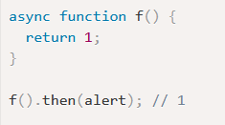  
    
  It can also explicitly return a promise (with resolve and reject):  
    
  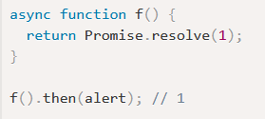
* **await** allow waiting on the async function to finish before proceeding  
    
  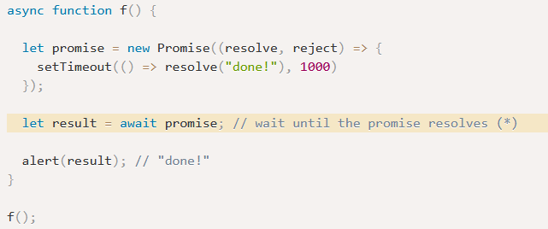
  + During this wait, the thread is stopped so it doesn’t waste CPU cycles
  + await can only be used inside async functions.   
    Note: if you need to use await in a high-level code, outside of an async function, you can always wrap it inside an anonymous function that executes immediately:  
      
    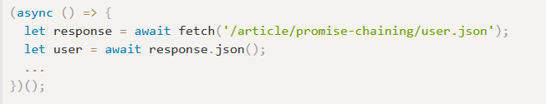
* error handling:
  + If the async function rejects, it behaves the same as if it threw an exception.
  + So, the await need to be in a try..catch block to handle it:  
      
    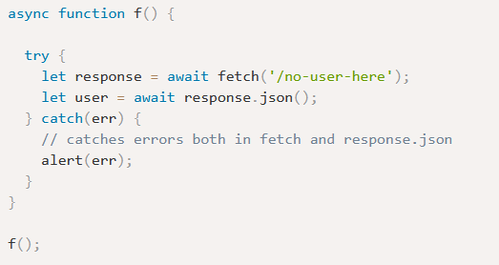
  + When we use async/await, we rarely need .then, because await handles the waiting for us. And we can use a regular try..catch instead of .catch. That’s usually (but not always) more convenient.
  + But at the top level of the code, when we’re outside any async function, we’re syntactically unable to use await, so it’s a normal practice to add .then/catch to handle the final result or falling-through error, like in:  
      
    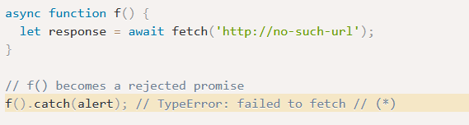
* Async/await works also with Promise.all:  
    
  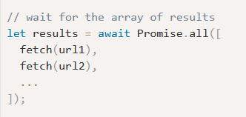  
    
  as before, we’ll surround this with try..catch to catch any rejects from the async functions.

# AJAX – Asynchronous JavaScript & XML

* Technology for making asynchronous requests to a server to transfer data, then load any returned data into the page. An asynchronous process has a couple key properties.
* The browser does not stop loading a page to wait for the server's response. Also, the browser inserts updated data into part of the page without having to refresh the entire page.
* Note: the page rendering can’t happen in parallel to the V8 call stack running. Therefore, like callback functions, it has to wait until the stack is empty before it can run! Since the ideal page-rendering speed is every 60 seconds

User experience benefits from asynchronous processes in several ways:

* Pages load faster since the browser isn't waiting for the server to respond in the middle of a page render.
* Requests and transfers happen in the background, without interrupting what the user is doing.
* When the browser receives new data, only the necessary area of the page refreshes.

These qualities especially enhance the user experience for single page applications.  
  
The data transferred between the browser and server is often in a format called JavaScript Object Notation (JSON). JSON resembles JavaScript object literal syntax, except that it's transferred as a string. Once received, it can be converted into an object and used in a script.

## Connect to DOM

* To make sure you’re your code executes only after the page has finished loading, you can attached a JavaScript ‘DOMContentLoaded’ event to the document:

document.addEventListener('DOMContentLoaded',  
 function() {  
 ….   
// You can register additional event handlers here. For example: document.getElementById(‘getMessage’).onclick=function() {…};  
});

* Note: JQuery and the DOM will bind the ‘this’ pointer of the evnetListener to the event that fires it. Therefore, if you need to use the object that this function belongs to, you need to hard-bind it yourself in the definition of it. Either by:   
  * hard binding it to this:

$("#open_help").bind("click",this.handleOpenHelp.bind(this));

* If you relay on ‘this’ being bound to the calling event, you can use lexical scoping to hard-bind to the object and use it instead of ‘this’ in your method:  
  var **self** = this;  
  …  
  // will use self for all internal calls within the obj:  
  **self**.useMyParameters;  
  ….  
  // will bind ‘this’ to the calling event:  
  document.addEventListener(“click”, function….);

## Change Element Content

document.getElementsByClassName('message')[0].textContent="Here is the message";

## XMLHttpRequest

You can also request data from an external source. This is where APIs come into play.

Most web APIs transfer data in a format called JSON. JSON stands for JavaScript Object Notation.

However, JSON transmitted by APIs are sent as bytes, and your application receives it as a string. These can be converted into JavaScript objects, but they are not JavaScript objects by default. The **JSON.parse** method parses the string and constructs the JavaScript object described by it.

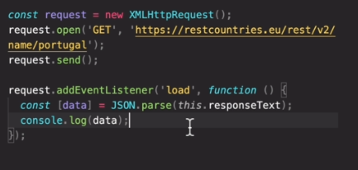

request.addEventListener - registers a function to be called when the AJAX call returned

## Event Listeners

Note: every time you change the DOM, a change event is triggered. It doesn’t just trigger on rendering but on every line that changes the DOM. So if you’re listening to changes, you might get more events than you expect.   
For example:

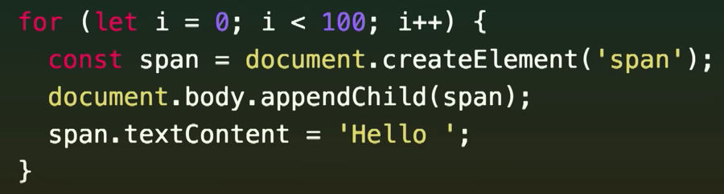

Will trigger 200 events (on the appendChild and on the spac.textContent)

**Mutation Observers** came to solve the issue of listening on specific events and getting triggered for every single event. Instead, they will be called just once for all these events. They solve it by using a new **microtasks queue**

# JSON

## Get and manipulate elements on a page:

In the HTML document:

<script type="text/javascript">

….

document.getElementsByClassName(<class name>)[0]

and then to manipulate it’s properties:

document.getElementsByClassName(<class name>)[0].style.<set any CSS property as you would in CSS file>

</script>

**‘document’** here is the DOM (the web page at its current state)

NOTE: Some property names are different between CSS and JS!! See Table in CSS: <https://developer.mozilla.org/en-US/docs/Web/CSS/CSS_Properties_Reference>

**True and False values in JS:**

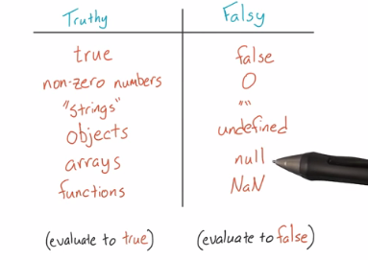

JSON is a popular and simple format for storing and transferring nested or hierarchal data. It's so popular that most other programming languages have libraries capable of parsing and writing JSON (like Python's [JSON library](https://docs.python.org/2/library/json.html)).

Internet GET and POST requests frequently pass data in JSON format.

JSON allows for objects (or data of other types) to be easily encapsulated within other objects. See the [MDN](https://developer.mozilla.org/en-US/docs/Web/JavaScript/Reference/Global_Objects/JSON) or [JSON.org](http://json.org/) for more details.

[This](http://www.copterlabs.com/blog/json-what-it-is-how-it-works-how-to-use-it/) is a fantastic deep dive from Jason Lengstorf about JSON and its ubiquitous use in the form of [AJAX requests](http://en.wikipedia.org/wiki/Ajax_%28programming%29).

## Always Lint your JSON!

With a mix of nested curly braces, square brackets and commas, it's easy to make mistakes with JSON. And mistakes mean bugs.

If you're generating JSON by hand, you should copy and paste your code into a JSON linter like [jsonlint.com](http://jsonlint.com) to quickly and easily find syntax errors. A linter is a piece of software that analyzes code for syntax errors. Some text editors, like Sublime Text, will automatically lint (or highlight) most syntax errors. But a JSON linter won't miss any syntax errors and you can rest assured that your JSONs will be properly formatted.

# TypeScript

* static (compilation time) , structural type system (as long as the variable has the expected properties with the right types, we’re good to go).

<https://www.typescriptlang.org/docs/handbook>

* Typescript playground: <https://www.typescriptlang.org/play>
* Fundamentals course: <https://www.typescript-training.com/course/fundamentals-v3/02-hello-typescript/>

A superset of JavaScript that add new features and type-safety to JavaScript.

Typescript is compiled (transcripted) into plain JavaScript before running in the browser.

Note: the type-checking is done only in compile time. Once the typescript code becomes plain javaScript – no type checking is performed (i.e. no type checking in run time).

* Typescript files have the extension .ts
* React typescript files have the extension .tsx

## Install

1. Install typescript:

npm install -D [typescript@4.2.2](mailto:typescript@4.2.2)

1. Init the typescript project:  
   npx tsc –init
2. Open your tsconfig.json and configure the followings:
   * Set “target” and “module” to ES2020
   * Uncomment “jsx” and leave it on “preserve”
   * Note: “strict” field determine how strict the typescript type checking is. If you’re converting a big project that will take a while, start with false and once you’ll finished with the migration turn it to ‘true’ otherwise, it will make it hard to migrate. For a small migration, you can leave it as ‘true’.
3. For every libraries we use that are not in typescript, we need to grab their type files so that typescript can recognize their types. For example:  
   npm install -D @types/react@17.0.2 @types/react-dom@17.0.1 @types/react-router-dom@5.1.7
4. Uninstall the ESLint for javascript (if previously installed) and install it for Typescript:
   1. Run npm uninstall @babel/eslint-parser
   2. Run npm install -D eslint-import-resolver-typescript@2.4.0 @typescript-eslint/eslint-plugin@4.16.1 @typescript-eslint/parser@4.16.1
   3. Change your package.json lint:
      1. entry to "lint":   
         "eslint \"src/**/*.{js,jsx,ts,tsx}\" --quiet",
      2. entry to format:  
         "format": "prettier --write \"src/**/*.{js,jsx, ts, tsx}\"",
      3. add a new scrip to check the types but not to re-write the javascript files:  
         "typecheck": "tsc --noEmit"
   4. Add the following to .eslintrc.json

// inside extends, above prettier rules

"plugin:@typescript-eslint/recommended",

// inside rules, generally a good rule but we're going to disable it for now

"@typescript-eslint/no-empty-function": 0

// inside plugins

"@typescript-eslint"

// replace parser

"parser": "@typescript-eslint/parser",

// inside parserOptions:

"project": "./tsconfig.json",

// add to settings object

"import/parsers": {

"@typescript-eslint/parser": [".ts", ".tsx"]

},

"import/resolver": {

"typescript": {

"alwaysTryTypes": true

}

}

* 1. Now if you run npm run lint you shouldn't see any type errors. But let's take this a step further: let's *enforce* type checking. This means we won't unchecked TypeScript in our codebase. This is something you'd turn on once *everything* is converted to TypeScript, otherwise it'll be very noisy. Since we're doing all the conversion now, let's add it now.

// under plugin:@typescript-eslint/recommended

"plugin:@typescript-eslint/recommended-requiring-type-checking",

## Compile to JS

tsc helloworld.ts

* in tsconfig.json we define which version of JS we want the compiler to transpile our code to. Usually ES2017 will give us all the modem JS features.
* If we need to support just one/two legacy systems, we might transpile to ES2017 to get a clean JS code and then use Babel to transpile to the legacy systems.
* tsc also creates a decleration file (file.d.ts) which contains the type information for the code.

## Convert an existing Javascript Projec to Typescript

1. Install typescript in the project (see Install)
2. Start with the leave-files in your app (that has the least dependencies) and continue up the dependency chain. For every .js file in your project:
   * Rename it to end with .ts (or .tsx for react files)
   * Convert the file.

## Create New React-Redux-Typescript Project

create-react-app my-app --scripts-version=react-scripts-ts

* tsconfig.json contains TypeScript-specific options for our project.
  + We also have a tsconfig.prod.json and a tsconfig.test.json in case we want to make any tweaks to our production builds, or our test builds.
* tslint.json stores the settings that our linter, [TSLint](https://github.com/palantir/tslint), will use. Note: tslint has been deprecated and we now have to use ESLint instead. To use ESLint, see the installation section above.
* package.json contains our dependencies, as well as some shortcuts for commands we'd like to run for testing, previewing, and deploying our app.
* public contains static assets like the HTML page we're planning to deploy to, or images. You can delete any file in this folder apart from index.html.
* src contains our TypeScript and CSS code. index.tsx is the entry-point for our file, and is mandatory.
* images.d.ts will tell TypeScript that certain types of image files can be import-ed, which create-react-app supports.

## Types

We can think of **types** as **sets** in TypeScript.

The relationships between types are determined by the properties they contain, not whether they were declared with some particular relationship. So for example, this is a valid TypeScript code:

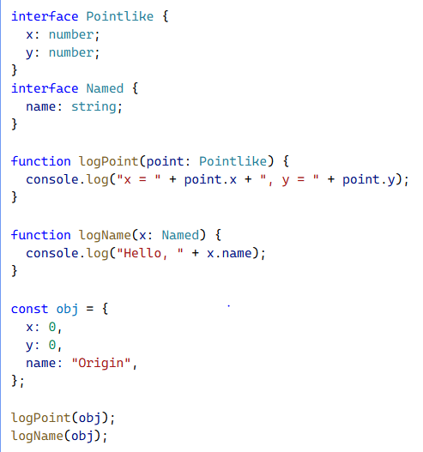

It’s like TypeScript treat all types as polymorphic on their members so as long as they contain the same members, they can be considered the same types (or subtypes)

This is also why this Empty use case is valid:

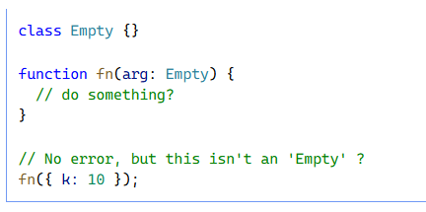

And the same for identical types:

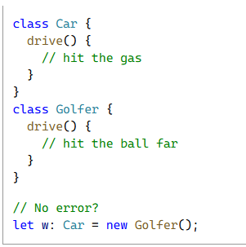

### Pre-Defined Types

Typescript supports the following types:

* Primitives:
  + string
  + number
  + Boolean
* Arrays:
  + number[]
  + Array<number>
* Objects:
  + Using a pre-defined type: { x: MyType }
  + Specify internal structure: { x: number; y: number }
  + With optional properties: { first: string, last**?**: string}  
    If last is not passed, it will automatically be assigned as undefined.
* Union types (or):
  + id: number **|** string  
    when using id, you might need to use conditions (e.g. if ( typeof id === “string”)…) in order to work with the passed value.
* Any:
  + We usually won’t use this. This is for when we don’t know and/or don’t want to specify the type. Using ‘any’ in our code directly or by using dependencies’ any types exposes us to errors with mis-using types.

#### Object Types

Defined the same as JS objects. For example:

let car = {  
 make: “Toyota”,  
 model: “Corolla”,  
 year: 2017  
}

So we can define the type as:

let car : {  
 make: string,  
 model: string,  
 year: number,  
 optionalProperty?: number  
}

* the optionalProperty is optional - if it exist, it will be a number. Otherwise, it will be undefined.
* To check for this in code, we can write:  
  if( typeof car.optionalProperty != “undefined”) {  
   .. execute safe code with optionalPropery as number  
  }  
  this is called a type guard.
* **Excess Property Checking:**If the user of the type is adding more fields to it but doesn’t have a way to access them in the future. For example, if a user will call a function that takes a car type with additional fields. If on the other hand the user will define an object with additional fields, they can still access the additional fields so there will be no problem.

##### Index Signature:

A way to define the type of a dictionary.   
For example, for this type of objects:

const phones = {

home: { country: "+1", area: "211", number: "652-4515" },

work: { country: "+1", area: "670", number: "752-5856" },

fax: { country: "+1", area: "322", number: "525-4357" },

}

where we want to be able to access them like a dictionary.

We define their type as:

const phones: {

[k: string]: {

country: string

area: string

number: string

} | undefined

} = {}

phones.fax.area <= this will show an error because phones can be empty.

#### Tuples

When we define an array type of mixed values that need to occur in a consistent order. For example, if we define our car as a touple:

let myCar**: [number, string, string]** = [  
 2002,  
 “Toyota”,  
 “Corolla”  
];

Tuples are useful when returning more than one parameter from a function. So for example, when we return [status, data].

WARNING: push/pop will mess up your tuple types and typescript will not catch it!

### Discriminated or Tagged Union Types

union type: when the type include ”|” for example:

let ID : number **|** string;

Commonly used when returning results with functions, together with a tuple of the results.

For example:

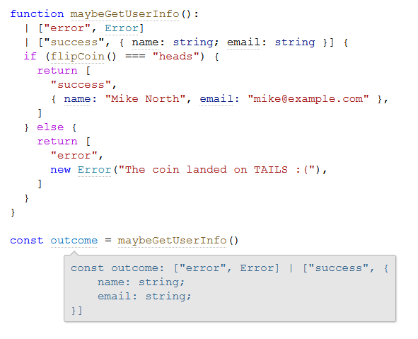

To process the response, we’ll examine the returned “error/success” tag:

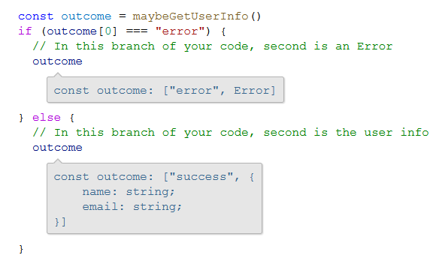

### Intersection (AND) Types

the overlap between two types.

### User-Defined Type Aliases and Interfaces

We can define additional type aliases/interfaces to use instead of explicitly writing the full types every time:

Object type:

**type** Point = {  
 x: number;  
 y: number;  
};

**Union type:**

**type** ID = number **|** string;

Interface:

**interface** Point = {  
 x: number;  
 y: number;  
};

Note: types and interfaces are very similar. The only different is that interface is easier to expend so use interface wherever possible.

### Literal Types

You can define types that can only have certain values:

type alignments = “left” | “right” | “center”;

type difference = -1 | 0 | 1;

this will allow typescript to warn you when you call a function with an invalid value:  


* const is also a literal type with one value:  
  const age = 6; // age is a literal type with the value of 6 only.

### Callable Types

We can define functions’ signature type:

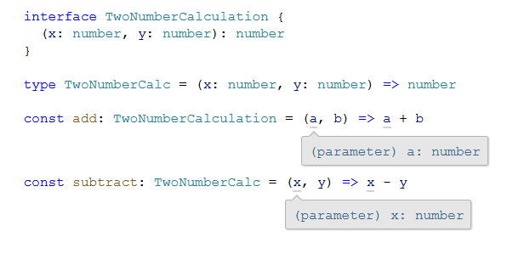

Note:

* since we defined the types for the whole functions, we don’t need to indicate the type of each parameter in the function definition itself (e.g. add/substract).
* Defining a function to return void means that this function’s return value should be ignored and not used. Defining the function to return undefined means that it actually has to return undefined. So it’s more restrictive.

##### Construct Signatures

Similar to call signature but they define a constructure (a function which is invoked with the ‘new’ keyword):

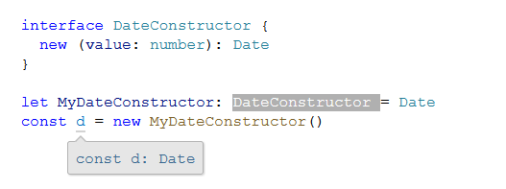

##### Functions Overload

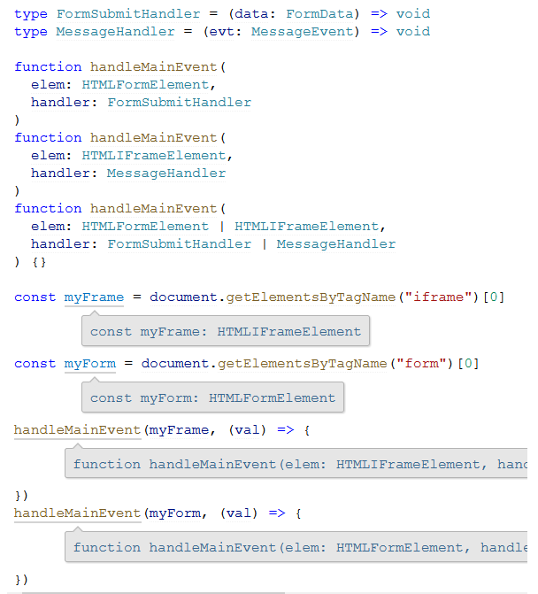

In order to define a function that can receive a specific combination of parameters - in the example above: either a

* HTMLFormElement with a FormSubmitHandler or a
* HTMLIFrameElement with a MessageHandler
* but no other options

we can define the two overloads of the function with just their signature:

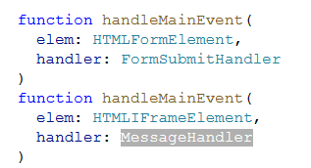

and then define the implementation of it:

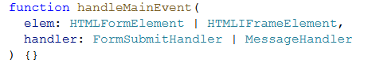

Note: that the implementation needs to include all the options for all the parameters (so for example, both HTMLFormElement and HTMLIFrameElement).

##### This Types

<https://www.typescript-training.com/course/fundamentals-v3/09-functions/#this-types>

For free-standing functions that refer to a ‘this’ that was passed by the invoking element (e.g. button click event), we need to pass is the ‘this’ element explicitly in order to let typescript know what the type of ‘this’ is. for example:

for this button:



Instead of defining the handle like this:

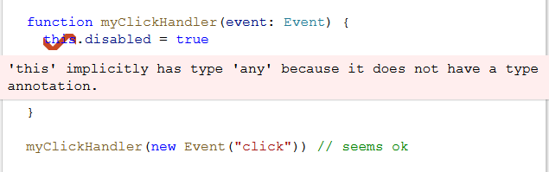

We should define it like this:

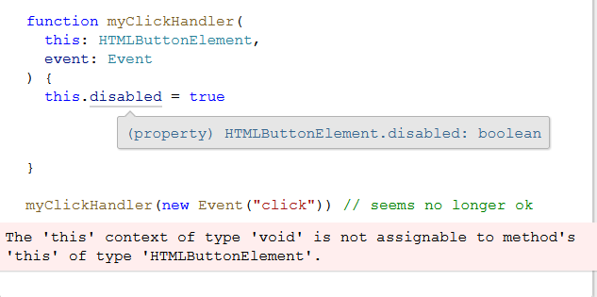

Note: we now can’t invoke the event handles in this way since it doesn’t pass the expected ‘this’ element. Therefore, this also force us to bind the element to the event handler before/when invoking it which is the right behaviour and will not produce any errors. for example, like the followings:

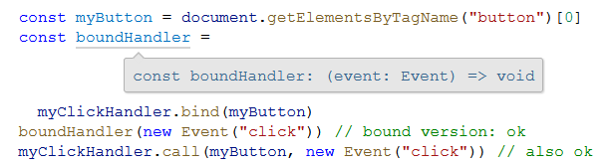

##### Best Practices

* explicitly define return types on functions. This allow better debugging where the errors appear in the functions and not where it’s called.

### Classes

TypeScript classes add some powerful and important features on top of traditional JavaScript classes.

class Car {  
 // define all the class’ members and their types:

make: string

model: string

year: number

// define all arguments to the constructor and their types:

constructor(make: string, model: string, year: number) {

this.make = make

this.model = model

this.year = year

}

}

let sedan = new Car("Honda", "Accord", 2017)

a shorthead for this, allowing the constructor to automatically create these fields for us:

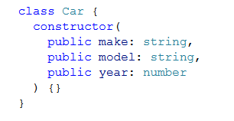

##### Access Modifiers

###### public/private/protected

Class’ fields/functions can be public/private/protected like in C#:

public visits: number = 0;

private ourName: string;

| **keyword** | **who can access** |
| --- | --- |
| public | everyone (this is the default) |
| protected | the instance itself, and subclasses |
| private | only the instance itself |

###### JS Private #fields

From TypeScript 3.8

allow using # instead of the ‘private’ keyword:

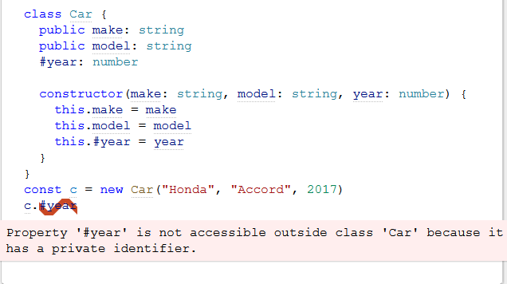

##### readonly

similar to const in JS or final in Java - protect the field from changing (after setting it for the 1st time in the ctor):

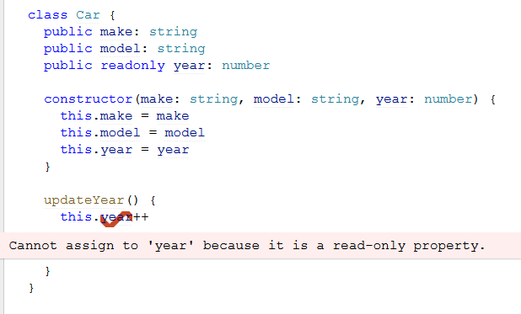

##### ctor

constructor(value: type){…}

in TypeScript, the constructor can also create fields automatically for us when the parameters include the access indicator (e.g. private/protected/public). For example:

**constructor**(**private** firstName: string,

**private** lastName: string) {}

public showName() {

alert(this.firstName + " " + this.lastName);

}

Constructor run order in typescript:

* + 1. super() is called
    2. class members (ctor parameters) are initialised
    3. class fields (initialised in the class, before the ctor) are initialised
    4. ctor’s body is run

### Top Types: Any & Unknown

A [top type](https://en.wikipedia.org/wiki/Top_type) (symbol: ⊤) is a type that describes **any possible value allowed by the system**. To use our set theory mental model, we could describe this as {x| x could be anything }

TypeScript provides two of these types: [any](https://www.typescriptlang.org/docs/handbook/2/everyday-types.html#any) and [unknown](https://www.typescriptlang.org/docs/handbook/2/functions.html#unknown).

#### any

You can think of values with an any type as “playing by the usual JavaScript rules”.

any typed values provide none of the safety we typically expect from TypeScript. Therefore, we won’t use it when there is a more appropriate types that we can use.

However, ‘any’ is not always a problem or a bug. Sometimes it’s the right thing to use. For example, console.log accepts any[] as its parameters. This is the right thing for this function and there’s no need to limit it.

#### unknown

Like any, unknown can accept any type.

However, it’s different from any in that that:

Unknown cannot be used without a type guard!

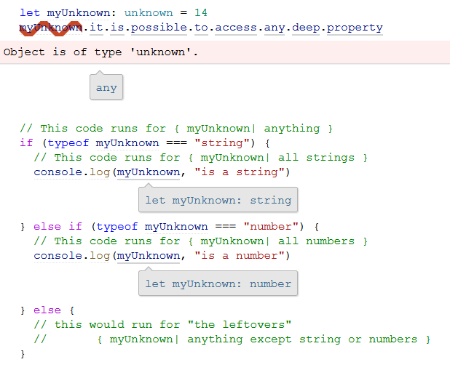

#### When to use top types

You will run into places where top types come in handy *very often*. In particular, if you ever convert a project from JavaScript to TypeScript, it’s very convenient to be able to incrementally add increasingly strong types. A lot of things will be any until you get a chance to give them some attention.

unknown is great for values received at runtime (e.g., your data layer). By obligating consumers of these values to perform some light validation before using them, errors are caught earlier, and can often be surfaced with more context.

### Bottom Type: never

A [bottom type](https://en.wikipedia.org/wiki/Bottom_type) (symbol: ⊥) is a type that describes **no possible value allowed by the system**. To use our set theory mental model, we could describe this as “any value from the following set: { } (intentionally empty)”

TypeScript provides one bottom type: [never](https://www.typescriptlang.org/docs/handbook/2/functions.html#never)

It is very useful in **Exhaustive Conditionals** - where you want to make sure that no one can reach an else/default statements.

For example,

we can define the following exception:

// from FrontendMasters course by Mike North:

class UnreachableError extends Error {

constructor(_nvr: **never**, message: string) {

super(message)

}

}

to handle and log receiving a never typed element (that should never happen).

Then, for the following types definitions:

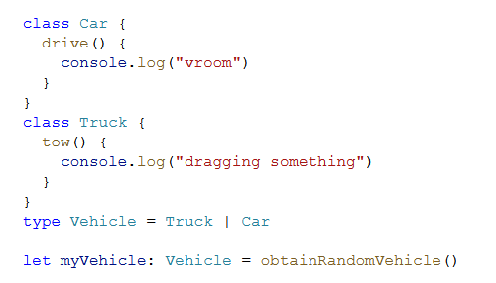

we can use this new exception to protect our if statements and turn it into an exhaustive conditional:

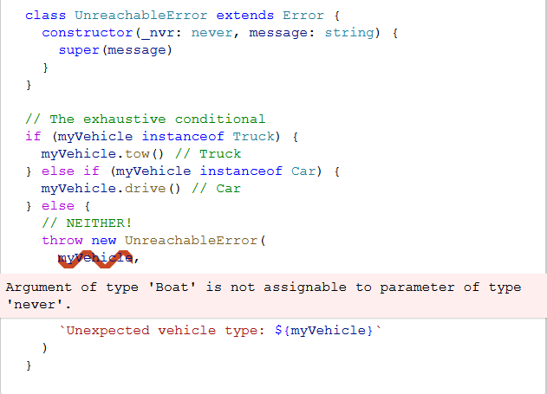

Now, one of three things will happen in that final else block

* We will have handled every case before reaching it, and thus we will never enter the final else block
* We will catch upstream code changes that need to be handled in this conditional at compile time (e.g., adding the Boat case)
* If somehow an unexpected value “slip through” and is not caught until we actually run the code, we will get a meaningful error message

### Type Guards and Narrowing

#### Built-in type guards

let value:

| Date

| null

| undefined

| "pineapple"

| [number]

| { dateRange: [Date, Date] }

// instanceof

if (value instanceof Date) {

value // let value: Date

}

// typeof

else if (typeof value === "string") {

value // let value: "pineapple"

}

// Specific value check

else if (value === null) {

value // let value: null

}

// Truthy/falsy check

else if (!value) {

value // let value: undefined

}

// Some built-in functions

else if (Array.isArray(value)) {

value // let value: [number]

}

// Property presence check

else if ("dateRange" in value) {

value // let value: {dateRange: [Date, Date];}

} else {

value // let value: never

}

#### User Defined Guard Types

##### <value> is <type>

interface CarLike {

make: string

model: string

year: number

}

let maybeCar: unknown

// the guard

function isCarLike(

valueToTest: any

): valueToTest is CarLike {

return (

valueToTest &&

typeof valueToTest === "object" &&

"make" in valueToTest &&

typeof valueToTest["make"] === "string" &&

"model" in valueToTest &&

typeof valueToTest["model"] === "string" &&

"year" in valueToTest &&

typeof valueToTest["year"] === "number"

)

}

// using the guard

if (isCarLike(maybeCar)) {

maybeCar

let maybeCar: CarLike

}

the return value of the isCarLike function (: valueToTest is CarLike) tells typescript that if we get true for this function, the tested value (maybeCar in our case) should be considered to be of the tested type (CarLike in this case).

##### asserts <value> is <type>

interface CarLike {

make: string

model: string

year: number

}

let maybeCar: unknown

// the guard

function assertsIsCarLike(

valueToTest: any

): asserts valueToTest is CarLike {

if (!isCarLike(valueToTest))

throw new Error(

`Value does not appear to be a CarLike${valueToTest}`

)

}

// using the guard

maybeCar // let maybeCar: unknown

assertsIsCarLike(maybeCar)

maybeCar // let maybeCar: CarLike

Note:

* + - Once we call assertsIsCarLike, we are guaranteed that we have a CarLike object and therefore, we don’t need to test it (if).
    - However, we should only use this for exceptional circumstances that warrants throwing an exception.

### Nullish Values

There are different kinds on nullish values in TypeScript:

* null - a defined value (!== undefined) that defines a ‘nothing’ value
* undefined - a value that wasn’t initiated (yet?)
* void - an indication to ignore the returned values of a void function

Notes:

* Make sure that your strictNullChecks is turned on to warn on using possible null values without checking them
* **Non-null Assertion Operator** – tells typescript that you know that the value of a variable is not null.   
  Warning: if the value is null, your code will break in runtime since ! only tells typescript not to fail the code. It doesn’t actually change how it works:  
  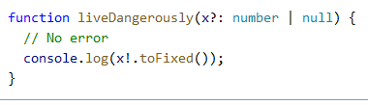
* **Definite Assignment Operator**Tells typescript that we know that a class field was initialized although it can deduce it from the code. This is useful for example in React life-time methods that initialize our classes.  
  So for example:  
  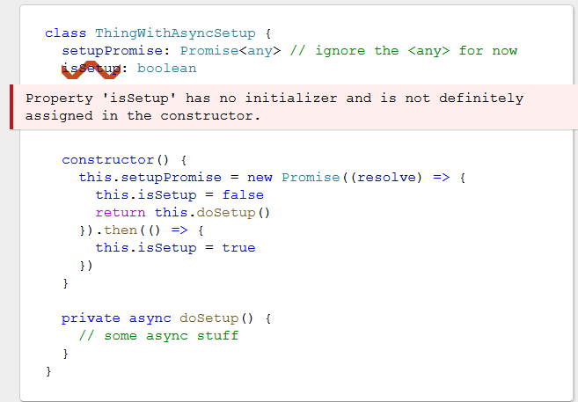
  + if we define isSetup as: isSetup**!**: boolean, typescript will understand that we know that it’ll be initialized before it can be used and will remove the warning.

### Generics

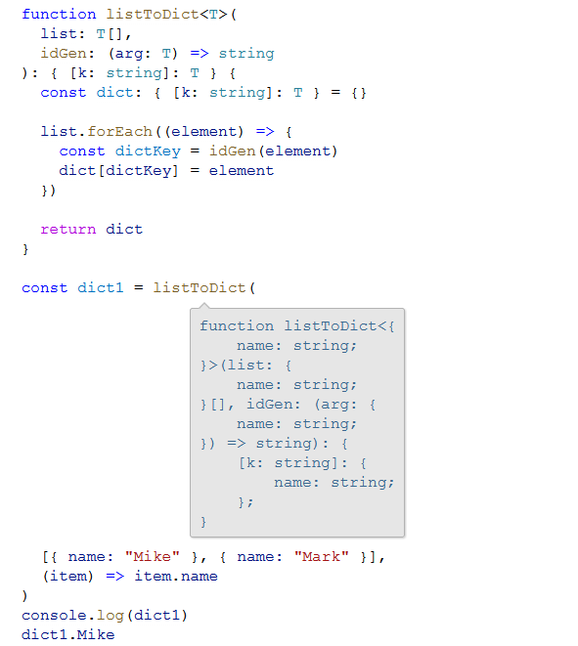

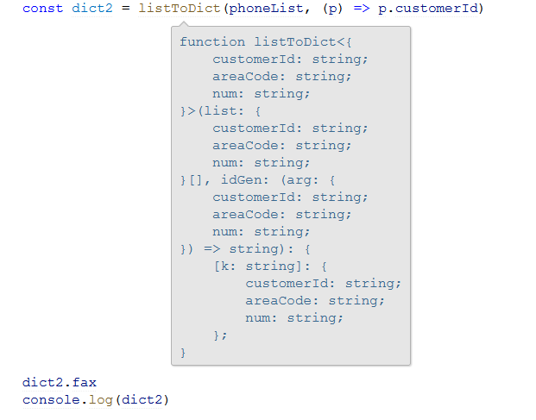

// Array.prototype.map, but for Dict

export function mapDict<T,K>(

  inputDictionary: Dict<T>,   
 callbackFunc: (value: T, name: string) => K

): Dict<K> {

  let result : Dict<K> = {};

  for( const key of Object.keys(inputDictionary)) {

    result[key] = callbackFunc(inputDictionary[key], key);

  }

  return result;

}

### Generic Constraints

Allow us to define the ‘minimum requirement’ for a type param, so we can remain flexible while still safely assume some minimal structure and behaviour.

export function  listToDict<T extends HasId>(list: T[])

: Dict<T> {

  const result: Dict<T> = {}

  list.forEach((item) => {

    result[item.id] = item;

  })

  return result;

}

### Type Assertions (casting)

When you know what is the expected type and typescript doesn’t:

const myCanvas = document.getElementById("main_canvas") **as** HTMLCanvasElement;

or:

const myCanvas = **<**HTMLCanvasElement**>**document.getElementById("main_canvas");

Note: TypeScript only allows type assertions which convert to a more specific or less specific version of a type.

If you need to convert between unrelated types, you can use ‘any’ as a middle conversion:

const a = (expr as any) as T;

## Syntax

<https://github.com/Microsoft/TypeScript-React-Starter#typescript-react-starter>

### Type Annotations

Type annotations in TypeScript are lightweight ways to record the intended contract of the function or variable. In this case, we intend the greeter function to be called with a single string parameter:

function greeter(person**: string**) {  
 return "Hello, " + person;  
}

If we’ll call the function with the wrong parameter:

let user = [0, 1, 2];  
greeter(user);

Compiling the TypeScript code will return an error. **Note:** although the compilation returns an error, the javascript file is still created and can be used. The TypeScript compiler just warns us that our code likely has bugs in it.

* You can also specify different possibilities for the type for example:  
  person: string | int

### Types

* define a more meaningful name for types
* declare the particulars of the type in a single place
* import and export this type from modules, the same as if it were an exported value

we can define, export and import types:

[export] **type** **Person** = {

firstName: string;  
 lastName: string;

}

#### Recursive Types

As of TypeScript 3.7:

type NestedNumbers = number | NestedNumbers[];  
  
const val: NestedNumbers = [3, 4, [5, 6, [7], 8], 39];

### Interfaces

Defines **object** types. Note: this means that they can’t be used to define union and and types.

Here we use an interface that describes objects that have a firstName and lastName field. In TypeScript, two types are compatible if their internal structure is compatible. This **allows us to implement an interface just by having the shape the interface requires, without an explicit implements clause**.

**interface** **Person** {  
 firstName: string;  
 lastName: string;  
}

function greeter(person: **Person**) {  
 return "Hello, " + person.firstName + " " + person.lastName;  
}

let user = { firstName: "Jane", lastName: "User" };  
document.body.innerHTML = greeter(user);

#### Extends

Allows:

* Defining interfaces that support multiple methods.
* Inherit implementation of a parent class

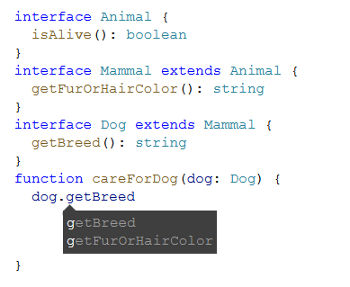

#### Implements

Used to define classes that implement (by contract) certain interfaces:

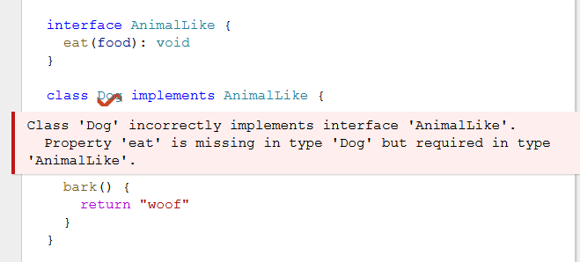

Like in Java, we can implement many interfaces but only extend one class.

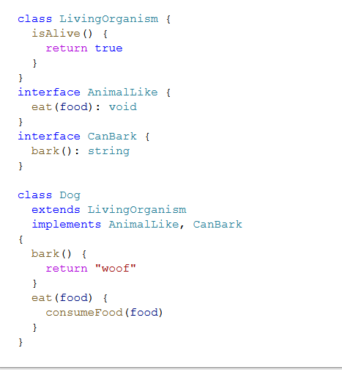

#### Open Interfaces

you can add to an existing interface (either yours or imported). Examples:

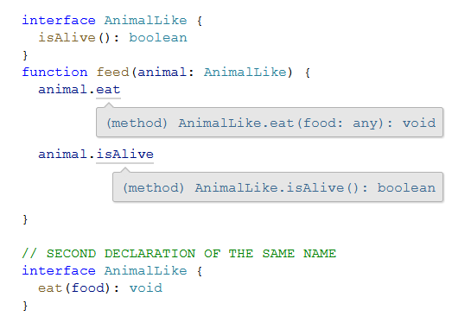

or when you need to add a global property to some object. For example:

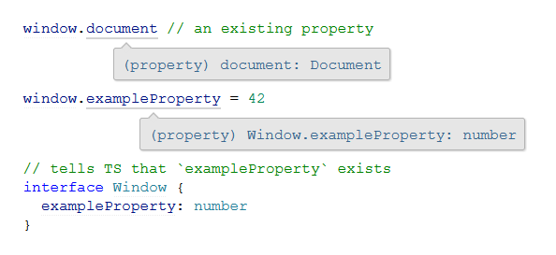

### Interface vs Type

As a rule of thumb (recommendation from React course):

Whenever we can, we should use interface to define types:  
**interface** Person {  
 firstName: string;  
 lastName: string;  
}

Only if we can’t, we should define it as a type:

**type** Person = {

firstName: string;  
 lastName: string;

}

* **If you need to define something other than an object type** (e.g., use of the | union type operator), you must use a type alias
* If you need to define a type **to use with the implements heritage term**, it’s best to use an interface
* If you need to **allow consumers of your types to *augment* them**, you must use an interface.

##### Functions

<access indicator> functionName(param: ofType,…): returnedType {…}

For example:

public showName(name: string): boolean {

alert(name);

return true;

}

##### Accessors (Properties in C#)

Similar to properties in C#:

* Setters:

**set** propertyName( value: Type) {

this.privateField = value;

}

* Getters:

**get** properyName() {

**return** this.privateProperty;

}

Here we’re going to create a Student class with a constructor and a few public fields. Notice that classes and interfaces play well together, letting the programmer decide on the right level of abstraction.

Also of note, the use of *public on arguments to the constructor is a shorthand that allows us to automatically create properties with that name*.

class Student {  
 public **fullName: string;**  
  
 constructor(**public** firstName**: string**, public middleInitial: string, public lastName: string) {

**this.fullName** = firstName + " " + middleInitial + " " + lastName;

}  
}

interface Person {  
 firstName: string;  
 lastName: string;  
}

function greeter(person : Person) {  
 return "Hello, " + person.firstName + " " + person.lastName;  
}

let user = new Student("Jane", "M.", "User");

document.body.innerHTML = greeter(user);

### Operations

* Optional chaining (?.) similar to conditional in c#:  
  let x = foo**?.**bar.baz();
  + this is a way of saying that when foo is defined, foo.bar.baz() will be computed; but when foo is null or undefined, stop what we’re doing and just return undefined.”  
    More plainly, that code snippet is the same as writing the following.

let x = foo === null || foo === undefined ? undefined : foo.bar.baz();

* The **??** operator can be used to provide a fallback value in case another value is null or undefined. It takes two operands and is written like this:

value ?? fallbackValue

* + If the left operand is null or undefined, the ?? expression evaluates to the right operand
  + **!.** – non null assertion operator  
    used to assert that its operand is non-null and non-undefined in contexts where the type checker is unable to conclude that fact. Specifically, the operation x! produces a value of the type of x with null and undefined excluded. Similar to type assertions of the forms <T>x and x as T, the ! non-null assertion operator is simply removed in the emitted JavaScript code.

### Extend React.Component

export **interface Props** {  
 name: string;  
 enthusiasmLevel?: number;  
}

class Hello extends React.Component**<Props, object>** {

render() {  
 const { name, enthusiasmLevel = 1 } = this.props;  
 if (enthusiasmLevel <= 0) {

throw new Error('You could be a little more enthusiastic. :D');

}

return (  
 <div className="hello">  
 <div className="greeting">  
 Hello {name + getExclamationMarks(enthusiasmLevel)}  
 </div>  
 </div>

);  
 }  
}

Notice that we defined a type named Props that specifies the properties our component will take. name is a required string, and enthusiasmLevel is an optional number (which you can tell from the ? that we wrote out after its name).

the class extends React.Component<Props, object>. The TypeScript-specific bit here are the type arguments we're passing to React.Component: Props and object. Here, Props is the type of our class's this.props, and object is the type of this.state.

#### Type Assertions

ReactDOM.render(  
 <Hello name="TypeScript" enthusiasmLevel={10} />,  
 document.getElementById('root') **as** HTMLElement  
);

This syntax is called a *type assertion*, sometimes also called a *cast*. This is a useful **way of telling TypeScript what the real type of an expression is** when you know better than the type checker.

The reason we need to do so in this case is that getElementById's return type is HTMLElement | null. Put simply, getElementById returns null when it can't find an element with a given id. We're assuming that getElementById will actually succeed, so we need to convince TypeScript of that using the as syntax.

TypeScript also has a trailing "bang" syntax (!), which removes null and undefined from the prior expression. So we *could* have written document.getElementById('root')**!**, but in this case we wanted to be a bit more explicit.

## Testing

### Enzyme

[Enzyme](http://airbnb.io/enzyme/) is a common tool in the React ecosystem that makes it easier to write tests for how components will behave. By default, our application includes a library called jsdom to allow us to simulate the DOM and test its runtime behavior without a browser. Enzyme is similar, but builds on jsdom and makes it easier to make certain queries about our components.

Let's install it as a development-time dependency:

npm install -D enzyme @types/enzyme enzyme-adapter-react-16 @types/enzyme-adapter-react-16 react-test-renderer

## Troubleshooting

* Could not find a declaration file for module ….
  + You need to install the type-definitions file for this module so that typescript can recognize its types. To do this:  
    > yarn add -D @types/{module-name}   
    for example:  
    > yarn add -D @types/react-router-dom

# Libraries

To know which library is supported for which browser, version etc – see <http://www.caniuse.com>

## Useful Libraries

* seamless-immutalbe – a library for creating and working with immutable objects. Very useful when working with redux.

To install: npm install seamless-immutable

* lodash – a library for iterating over and manipulating arrays, objects and strings. Contains a lot of syntactic sugar for data manipulations. Nicknamed Linq for JS.

Examples:

import * as _ from "lodash";

…

get subtotal() : number {

return **_.sum**(this.items, i =>

(i.unitPrice * i.quantity));

}

## JQuery

A very popular library in java script that allow easy manipulation of web pages.

Check out the [jQuery website](http://jquery.com/) to learn more

JQuery methods: <http://www.w3schools.com/jquery/jquery_ref_html.asp>

**Directly work on elements in a DOM:**

Using JQuery, we can directly access and manipulate DOM elements using CSS syntax to refer to elements. For example:

* $(“#element-id”)
* $(“.element-class”)

# Tools

Json2ts – generate TS types declarations from json data.

## Bundling

Webpack, browserfy – boundle all the javascript files into one, compressed file.

### Parcel

A few simple, smart bundler that doesn’t require any setup to start working with.

1. To install:  
   > npm install -D [parcel@1.12.3](mailto:parcel@1.12.3)
2. In your package.json, add the script:

“dev”: “parcel src/index.html”

## Transpilers

“compilers” that translate the code from one version of JS to another version/format of JS or to combine many JS file into one. This is used in order to translate the code to one that is supported by older browsers.

Babel, jscodeshift – compile code to make it runnable (e.g. from typescript or ES6)

Babel will create .map files that allows developers to debug their code locally (link the packaged .js files to the source code). Make sure no to send these files to production!

### Babel

Babel is a core part of the JavaScript tooling ecosystem. At its core it is a transpilation tool: it takes that looks one way and transforms it it into a different looking set of code. One of its core uses to transform futuristic JavaScript (like ES2021) to an older version of JavaScript (like ES5 i.e. JavaScript before 2015) so that older browsers can use your newer JavaScript. Babel also handles things like JSX for us and it can handle TypeScript too.

To work with parcel 1.x install: npm install -D @babel/core@7.12.16 @babel/preset-react@7.12.13

Create a file called .babelrc in your home directory and put this in there:

{

"presets": [

[

"@babel/preset-react",

{

"runtime": "automatic"

}

]

]

}

To control which browsers your code support (for different tools, including babel and parcel) , you can add this in your package.json:

"browserslist": [

    "last 2 Chrome versions",

    "last 2 Firefox versions"

  ]

You can see which browsers are covered by your string here: <https://browserslist.dev>

## Toolkits

Can create initial custom-project/code. For example, the create-react-app

# NodeJs

# Testing

## Unit Testing

### Jest

The most common framework.

**Install:**

* + - <https://basarat.gitbook.io/typescript/intro-1/jest>

To Run:

* + - Add “test”: “jest” to your scripts in package.json
    - To run all tests:  
      > npm t

In order to debug unit tests in VSCode:

* In the left menu, press the ‘Run and Debug’ button and press ‘create a launch.json file’.
* This will create a .vscode directory at your project’s root and a launch.json inside of it.
* Add the following under “configuration”:

{

            "type": "node",

            "request": "launch",

            "name": "Jest run current file",

            "program": "${workspaceRoot}/node_modules/jest/bin/jest.js",

            "cwd": "${workspaceRoot}",

            "args": [

                "${fileBasenameNoExtension}",

                "--runInBand",

                "--verbose",

                "-i",

                "--no-cache"],

            "console": "integratedTerminal",

            "internalConsoleOptions": "neverOpen"

          },

* --coverage – will return the tests coverage. Note that you need to configure in jest config file which files to include in the coverage check.

Test file skeleton example:

import { myBeverage } from “./beverage”;

describe('my beverage', () => {

test('is delicious', () => {

expect(myBeverage.delicious).toBeTruthy();

});

test('is not sour', () => {

expect(myBeverage.sour).toBeFalsy();

});

});

* describe - the test suite (use noun - what are we testing?)
* test (or ‘it’) - the test itself (use verb - what is the expected behaviour?)

#### Mocking

Three types of mocking in jest:

* jest.fn: Mock a function
* jest.mock: Mock a module
* jest.spyOn: Spy or mock a function

Auth.signIn = jest.fn().mockImplementation(

() => {

// return whatever you want to test

});

### Mocha

// "use strict";

var assert = require('assert');

// require("js_algorithms.js");

describe('Array',function() {

describe('#indexOf()', function() {

it('should return -1 when the value is not present', function() {

assert.equal(-1, [1,2,3].indexOf(4));

});

});

});

// Create a test suite (group) called Math

describe('Math', function() {  
  
 // add a test hook  
 beforeEach(function() {  
 // ...some logic before each test is run  
 })

// Test One: A string explanation of what we're testing

it('should test if 3*3 = 9', function(){

// Our actual test: 3*3 SHOULD EQUAL 9

assert.equal(9, 3*3);

});

// Test Two: A string explanation of what we're testing

it('should test if (3-4)*8 = -8', function(){

// Our actual test: (3-4)*8 SHOULD EQUAL -8

assert.equal(-8, (3-4)*8);

});

});

##### Install:

$ npm install // will install all the required dependencies according to the package.json file.

##### Set Up:

In the package.json add:

"scripts": {

"test": "mocha"

}

##### Structure

1. **describe()** is simply a way to group our tests in Mocha. We can nest our tests in groups as deep as we deem necessary. describe() takes two arguments, the first is the name of the test group, and the second is a callback function.

describe('string name', function(){  
 // can nest more describe()'s here, or tests go here  
});

1. **it()** is used for an individual test case. it() should be written as if you were saying it out loud: “It should equal zero”, “It should log the user in”, etc. it() takes two arguments, a string explaining what the test should do, and a callback function which contains our actual test:

it('should blah blah blah', function(){  
 // Test case goes here  
});

##### Assertion Libraries (e.g. Chai):

Within our testing framework (Mocha), we can use assertion libraries. **An assertion library is a tool to verify things are correct -** It’s what actually verifies the test results.

Note that we don’t need to use an assertion library, but they make testing **way** easier. Mocha allows us to use any assertion library we wish. In the above example (and for all of the other examples), we’re using Node.js’ built-in [assert](https://nodejs.org/api/assert.html) module. Hence this line of code where we require the assert module:

##### Running

Form the command-line:

$ npm test

To run a single test, from the root of the project:

$ mocha -g <it/describe name as a regular expression>

Note: if you changed the names, you might need to run the npm test first to compile the whole names list.

Example:

it('logs a', function(done) {  
 console.log('a');  
 done();  
});  
…

$ mocha -g 'logs a'

##### Debugging

* 1. run the test(s) with inspect-brk flag: $ mocha --inspect-brk
  2. in VS-Code:
     1. choose the “Debug Mocha Test” debugging configuration:  
        in launch.json in your project’s root directory:

{

"type": "node",

"request": "launch",

"name": "Debug Mocha Tests",

"address": "localhost",

"port": 9229,

"sourceMaps": false

}

* + 1. Set break point(s) in your test
    2. Press the green run button

## Chai

Chai is a BDD / TDD assertion library for [node](http://nodejs.org) and the browser that can be delightfully paired with any javascript testing framework.

### Installation

##### Node.js

1. $ npm install chai
2. See js_sandbox/package.json for additional settings

##### Browser

Include the chai browser build in your testing suite.

<script src="chai.js" type="text/javascript"></script>

This will provide chai as a global object, or define it if you are using AMD.

### Test

## End-To-End Testing

### Cypress

##### Install:

1. Navigate to your project’s root directory
2. Install cypress locally as a dev dependence for your project:  
   $ npm install cypress --save-dev

# How to debug

1. Get to the page/scenario you want to test
2. Right click an element->inspect Element
3. Copy one of the element’s properties and search for them in the Debugger tab (in all files)
4. This is where the code should go on choosing the address. If it doesn’t there is a problem with wiring of the function to the button.
5. You can also try looking at the EventListeners
6. $0. – the selected element in the page.
7. When the script runs in the browser, we have access to its functions and we can call them. When you breakpoint on a line, you can see all its internal variables and functions and you can call them from the console.

A.on("a:button-group", function () { console.log(arguments()) })

A.on("a:button-group:toggle", function () { console.log(arguments()) })

var el = document.createElement("span")

el.className = "class1 class2"

el.setAttribute("data-a-button-group-name", '{name: "asdf"}')

el.outerHTML

## JavaScript Debugging Calls

Taken from [Advanced console.log Tips & Tricks](https://medium.com/nmc-techblog/advanced-console-log-tips-tricks-fa3762930bca):

|  |  |
| --- | --- |
| **Syntax** | **Description** |
| console.dir(object) | Prints an object’s properties in the a clean expandable list |
| console.assert(assertion, obj1, …, objN) | Only log something if a condition is **false** |
| console.count(string) | Increment and log a counter by 1 everytime **string** is logged |
| console.table(object) | Print an object in a visually nice table representation with labelled rows for each of the object’s properties |
| console.time(string)/timeEnd(string) | Log amount of time between calls |
| console.trace(string) | Log a message along with a stacktrace of the code |
| console.group(string)/groupEnd() | Group log messages together under collapsible heading |
| console.log("%s message”, css) | Print a message using CSS, for big font or color output for example |

## Chrome Debugging

1. In Dev-tools: Cmd-Shift-P – opens a commands panel that you can types a lot of commands.
2. If you select an element in the Elements tab, you can get the JS reference to it through $0 so you can inspect or manipulate it.
3. Breakpoints:
   * XHR/fetch – will break when the browser send a request to URL. You can add a URL that contains some partial path and it will break there.
   * On the DOM elements themselves, you can set breakpoints when the DOM is changing (in the elements tab -> right click)
4. Search:
   * In the Console: Cmd-opt-F (Ctrl-shift-F) – search for string in any file (js/html etc)
5. Copy full network request in any format you want (like curl request): choose request in network tab, right click…
6. Console:
   * Cmd+L – clear console
7. You can use snippets to write partial code you can run in the debugger (need to figure out how – a bit clunky..)

## Troubleshooting

1. **Browser Regeneration Runtime Error:**
   * From your browserslist parameter in package.json not being correct
   * To fix:
     + Delete your .cache and dist directories and restart your server.

# Packaging

## Npm

**npm** is a [package manager](https://en.wikipedia.org/wiki/Package_manager) for the [JavaScript](https://en.wikipedia.org/wiki/JavaScript) programming language. It is the default package manager for the JavaScript runtime environment [Node.js](https://en.wikipedia.org/wiki/Node.js). It consists of a command line client, also called npm, and an [online database](https://en.wikipedia.org/wiki/Online_database) of public and paid-for private packages, called the npm registry.

### Init

npm init -y

will initialize the project and will create the initial package.json file.

### Install Dependencies

npm install

will check the package.json and will install all the required dependencies.

### Install Package

Will add packages into the package.json as requirements and will download them into the project.

npm install [-g] <package name>

Can also use: npm i…

-g – install the package globally. Otherwise, will install it on the current folder only.

-D – install as devDependencies only (not in production code)

--save-dev – will save as a development-dependency in package.json

### Scripts

You can define any commands you want in your package.json under “scripts” and then you can run them using npm run my-script

For example:

"scripts": {

"my-script": "parcel src/index.html",  
 "lint": "eslint \"src/**/*.{js,jsx}\" --quiet"

}

With npm scripts, you can pass additional parameters to the command if you want. Just add a -- and then put whatever else you want to tack on after that. For example, if I wanted to get the debug output from ESLint, I could run npm run lint -- --debug which would translate to eslint **/*.js --debug.

### Run local host server

npm run dev

// the following scripts will monitor our files and will restart the server automatically whenever they change:

"dev": "nodemon --exec yarn restart",

"restart": "rimraf dist && yarn build && yarn start",

// for prod, we will use the following:  
"start": "node dist/index.js"

### Useful Commands

* The latest available version on the npm registry:

npm view <package-name> version

* The versions of all local [or -g for global] installed packages:

npm list [-g]

### npx

used for executing commands either from a local node_modules/.bin, or from a central cache, installing any packages needed in order for <command> to run.

<https://www.npmjs.com/package/npx>

## Yarn

Another package manager

Yarn’s advantage over npm is that:

* Yarn install packages in parallel so it’s much faster than npm usually
* Yarn fixed some security holes that were present in npm.
* Yarn updates another lock-file (yarn.lock) with the exact version of any package so that when installing on another machine, you can guarantee that you both work with the same package version. This is since package.lock locks down a range of packages (e.g. 1.3.x) and not a specific one.
* Note: both yarn and npm take the packages from the npm repository so the packages themselves are identical.

<https://www.sitepoint.com/yarn-vs-npm/>

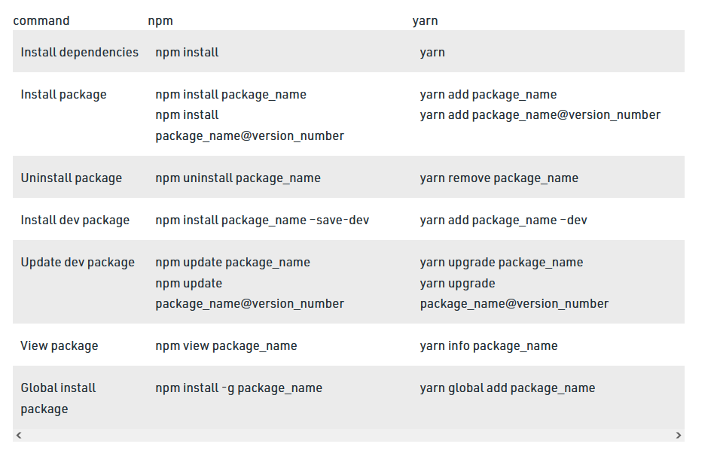

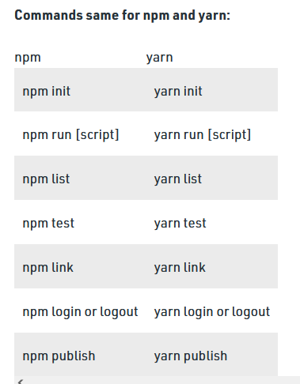

## Package.json

* “dependencies”: {  
   all the dependencies that will be used by all versions of the app (both development and deployed).  
  }
* “devDependencies” : {  
   dependencies for development-environment only.  
  }

# Environment Setup

To start a js project:

1. Create the project directory and /src and /tst subfolders under it.
2. Init the project: npm init -y
3. Install formatters and linters (see instructions in JavaScript.docx):
   1. Prettier
   2. ESLint
4. Bundler – to bundle all your .js files to prepare them for running. You can use Parcel
5. Install Transpiler (e.g. Babel)
6. To run your code locally: npm run dev

# JS Patterns

* const - will only protect the reference from changing. If you want to protect the actual data (e.g. in an object or array), use   
   Object.freeze(obj);  
  instead
* Strategy - use JS mixins to add a behavior to different classes/objects:  
  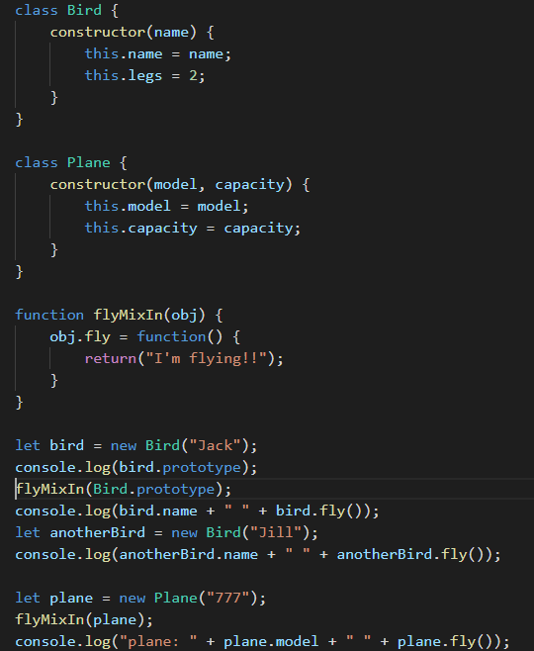
* Private properties:
  + In JS, the only way to make a class/object members private is through closure:  
      
    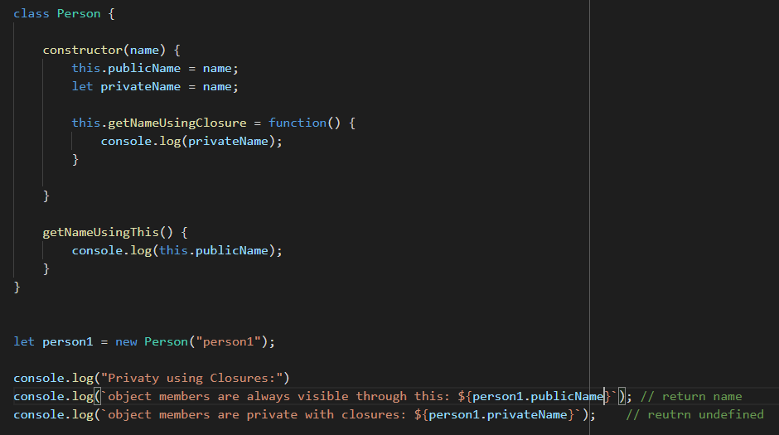
  + Modules: you can create a module by using Immediately Invoked Function Expression (IIFE):  
    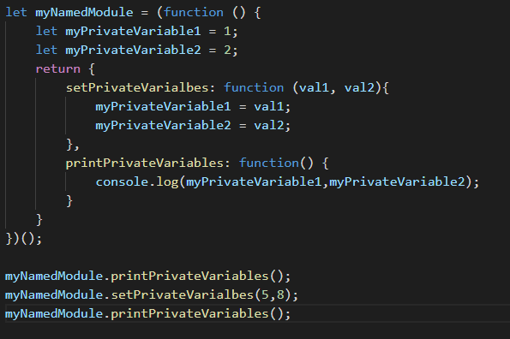  
      
    this allows you to easily package your variable and functions in a private scope and protect the global scope from contamination.

# JS Anti Patterns

* defining functions in constructors:  
  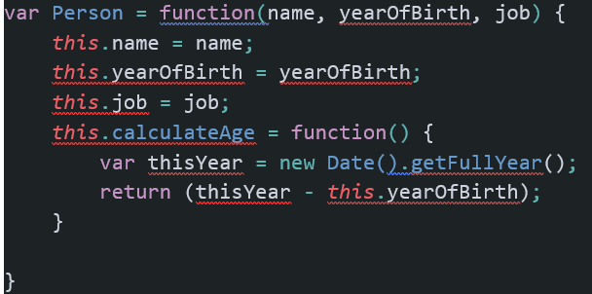

This will duplicate the function for every Person object. A better way is to define it in the prototype itself:

Person.porotype.calculateAge = function(){…}

or in the class definition:

* shadowing - is overriding the definition of the class’ prototype method with an object method with the same name. The issue is that you won’t be able to call the prototype’s method easily (see Prototypes):  
     
  The better way to do this will be to call the object’s method by a different name. Then they are both available easily.
* **Smelly Bindings:**  
  If your code use the ‘this’ keywork but all/most your calling code is using hard-binding to work around the dynamic ‘this’ binding (myObj.meMethod.bind(myObj)…)– this is a code smell that you probably want to use a module with closure with lexical scoping instead of the ‘this’ dynamic scoping.  
  Remember dynamic and lexical scoping don’t mix in JS.

# JS Traps

The things to watch out for when writing JS code:

* **Invalid ‘this’ in function:**  
  This is connected to the calling object (dynamic scope) and not to the defining object (lexical scope). Therefore, if a method is called without its object, it will lose its ‘this’ context. For example:  
  setTimeout(myObj.myMethod,…); - the myMethod ‘this’ will be bound to undefined (strict mode) or to the global object (non strict mode) (done under the hood by the setTimeout function).  
  Therefore, if we want it to be bound to the calling object, we need to hard-bind it:  
  setTimeout(myObj.myMethod.bind(myObj),…);  
  Notes:
  + In the browser, the global object is the window
  + .call(), .apply() or .bind() can be used to hard**-**bind the new to the correct object (see above)
* **Prototype Properties** - are not static members, only default values!
* Js doesn’t enforce that the calling code passes the correct number of variables to the function.
* eval() method – very problematic (see Scoping). Recommendation: never use it unless there is absolutely no other option. This is also true for calling setTimeout with the string syntax which actually uses the eval mechanism.
  + with() keyword – also create an additional scope and prevent compiler optimisations. In strict mode, it’s not allowed anymore.

# Resources

* Frontend Masters: <https://frontendmasters.com/>
* Kyle Simpson (You don’t know java script):
  + <https://me.getify.com/>
  + <https://github.com/getify/LABjs> - dynamic script loader that can work
  + Grips – templating engine
  + Browser versions are dead – recommended lecture from Kyle.
  + <http://YouDontKnowJS.com>
  + <https://github.com/getify/You-Dont-Know-JS/blob/2nd-ed/get-started/ch1.md>
* Very highly recommended book (recommended by Kyle Simpson):
  + High performance JavaScript – Nicolas sekes (?)
  + JavaScript Patterns – Stepheno (?)